Headline News
October 18, 2026
 | Tesla unveils flying sports car  Production on new Roadster, which can thrust itself into the air in short spurts, won’t begin until 2028 as Musk admits it’s not ‘a safety-optimized car’. (link)  - Would you like to buy this flying car in 2028?  - Would you rather have a flying car or a self-driving car?  - Do you think flying cars will become common in the future?  - How do you think transportation will change in the next 20 years?  - Are you happy with your current car?  - What’s your dream car?
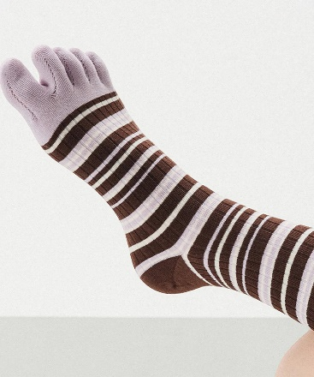 | Toe socks are having a wellness moment  Toe socks have resurfaced as a wellness accessory after singer and JYP Entertainment founder J.Y. Park touted their health benefits on a television variety show. "When the five toes move independently, they help maintain the body's balance," Park said. "You live the same life but feel less tired."  - How many pairs of toe socks do you own?  - Do you believe that they are good for your health?  - What are the pros and cons of wearing toe socks?  - What wellness products have you tried recently?  - Do you ever listen to J.Y. Park’s music or music from JYP Entertainment?
 | Mountain trail closed for nearly 60 years opens in Seoul  Starting Saturday, October 17th at 9 a.m., visitors will be able to explore the last restricted section of Bugaksan, a stretch of mountain behind Cheong Wa Dae. The trail offers sweeping views of Seoul, as well as the grounds of Cheong Wa Dae and Gyeongbokgung Palace.  - Would you like to hike this newly opened trail?  - Why do you think the trail was closed for so long?  - When was the last time you went for a hike?  - Tell me about your most memorable hiking experience.  - Does food taste better at the top of a mountain?  - Would you rather hike with someone who talks too much or stops to take selfies with you every 5 minutes.
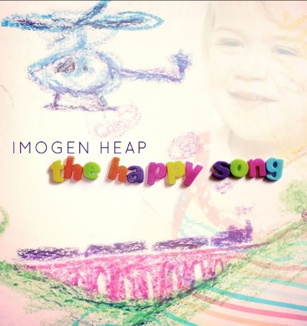 | This song was scientifically designed to soothe babies — and 470 million streams prove it works  “The Happy Song”, which celebrates its 10th anniversary this week, was a collaboration between two psychologists and Grammy-winning musician Imogen Heap. Over 2,000 parents were surveyed and different melodies were tested on babies. The result is a song which combines a catchy melody, playful lyrics, animal noises, laughter, and expressive, high-pitched sounds that capture babies’ attention. It was also designed to appeal to parents, with a melody that woudn’t become irritating after repeated listening. (link)  - Do you think this song really works to soothe babies?  - Can songs be scientifically engineered to affect our emotions?  - Do you have a favorite lullaby?  - Would you rather listen to The Happy Song or Baby Shark?  - What kind of music do you usually listen to?  - Do you think animals enjoy music?  - If you were a boxer, what would your entrance song be?

