Headline News
Octoboer 15, 2026
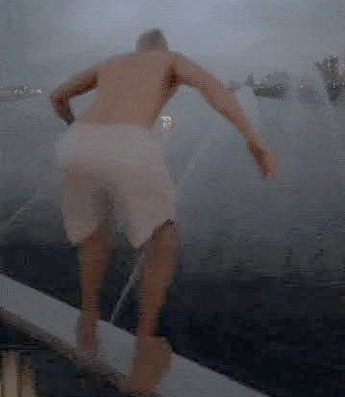 | Han River plunge draws ire  A group of apparently foreign men have stirred controversy after climbing the railing of Seoul’s Banpo Bridge and plunging into the Han River. No accidents or injuries were apparent. The incident drew mixed reactions online, with some raising concerns over the risk of accidents.  - Should people be allowed to jump off Banpo bridge? Why or why not?  - Should these men be punished? How?  - Have you ever done something dangerous for fun?  - Would you jump off Banpo bridge for $1 billion?  - Why are men so crazy?  - What is your favorite bridge?
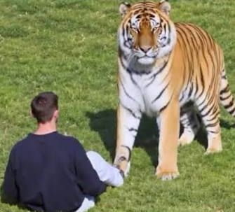 | Tiger that killed man who entered enclosure won’t be euthanized  A wildlife park in the United Kingdom reportedly said it will not euthanize a tiger that mauled a man to death after he entered its enclosure.  - Should the tiger be euthanized?  - Why do you think the man entered the enclosure?  - What would you have done if you saw someone jump into the enclosure?  - Who is most responsibe for this tragedy: the man, the tiger, or the zoo?  - When was the last time you visited the zoo?  - Which is your favorite animal to see at the zoo?  - If you were an animal, would you rather live in a zoo or in the wild?
 | Think twice before posing with hand signs  The classic 'V' hand sign may now pose a security risk, with AI technology making fingerprint theft easier than ever.  - Have you ever made a V sign when you take photos?  - What is your favorite way to pose for the camera?  - Will you stop using hand signs in photos from now on?  - Have you ever been a victim of ID theft?  - Do you upload your photos to social media sites?  - What advice would you give someone who wants to protect their privacy?
 | Thailand suing Facebook over video of crop top-wearing king  Thai authorities took offence to an unflattering video of their king sporting a crop top in Germany. King Maha Vajiralongkorn has been photographed wearing a crop top on several separate occasions. At least 289 individuals have faced formal charges for insulting or defaming the monarchy, and around 30 people are currently in prison.  - Should the King be allowed to wear a crop top in public?  - Should Facebook remove the videos and pictures?  - Do you think these photos are real or fake?  - Would you feel comfortable mocking the president of Korea?  - Should the Korean monarchy be restored?  - Would you like to be a king or queen? Why or why not?

