Headline News
September 23, 2026
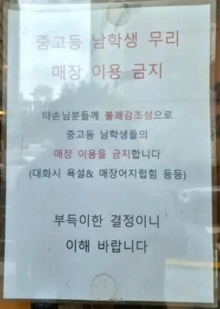 | Cafe ban on teenage boys sparks discrimination debate in Korea  Following the emergence of "no-kids zones" that bar children, a "no male student zone" has now surfaced. While some view the policy as an exercise of a business owner's right to run their business as they see fit, critics argue it illustrates a growing trend of exclusion and discrimination against specific demographic groups.  - Is this a good idea? Why or why not?  - Do you think that male teens are worse than females?  - Should private businesses have a right to ban anyone they want?  - Would you visit this café?  - Is it possible to ban the behavior rather than the group?  - Where is your favorite café? Why do you like it?
 | Kids are lining up at this Staten Island bodega with report cards  Over the past three years, thousands of students have come through Zach’s Finest Deli’s doors. Located in Staten Island’s Port Richmond neighborhood, it’s where manager Wail Alselwi, runs his “Grades for Grabs” initiative, which incentivizes kids to earn good grades with free snacks and prizes.  - Is this a good idea? Why or why not?  - Should schools give money or prizes for good grades?  - What motivated you to study hard when you were a student?  - Do you think competition between students is good or bad?  - What motivates you to study English each week?
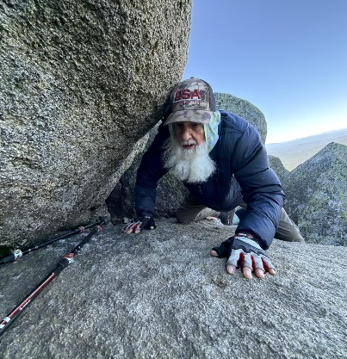 | At 91, Dale 'Grey Beard' Sanders reclaims record as oldest hiker to complete the Appalachian Trail  At 91, Dale “Grey Beard” Sanders became the oldest person to complete the 3,529-km Appalachian Trail, finishing the journey in 359 days.  - Would you like to hike the Appalachian Trail? What about the Camino de Santigo?  - When was the last time you went for a hike?  - What was the longest hike you’ve ever taken?  - What would be the hardest part of hiking for almost a year?  - Where is your favorite place to go hiking?  - Would you rather hike alone or with other people?
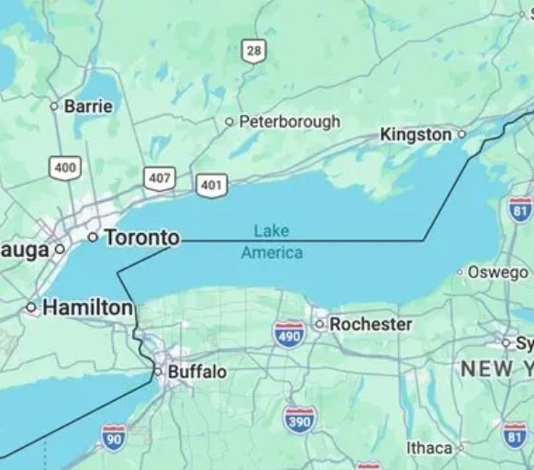 | Apple, Google rename Lake Ontario to Lake America after Trump order  MapQuest is No. 1 on the App Store after refusing to change Lake Ontario’s name.  - Do you think Lake America is better for Americans?  - Are there any places that you think should be renamed?  - East Sea vs Sea of Japan. How do you feel about this controversy?  - Which map app do you use?

