Headline News
September 17, 2026
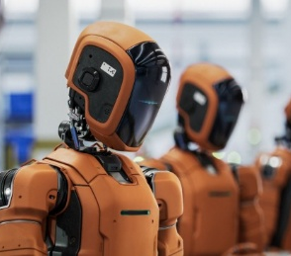 | Anthropic Staffers Say AI May Kill Us All Within 10 Years  There’s more than a 10% chance that AI could kill "all humans" in the next decade and the company lacks a clear plan to make super-intelligent systems safe.  - Are you worried?  - How might AI kill us all?  - When was the last time you used AI?  - Should we destroy AI now before it destroys us?  - If we can give AI emotions, will it be more or less dangerous?
 | German TikToker draws ire over DJ stunts on Seoul Metro  A German social media influencer has drawn criticism after posting videos of himself playing loud music through a large speaker and dancing on subway trains in Seoul.  - Would you be entertained or disturbed by this DJ?  - Which is worse, influencers on the subway or salespeople?  - Have you ever seen something strange on the subway?  - Do you enjoy seeing buskers in public parks or tourist areas?  - What is your favorite subway line?
 | Korea approves jeans for civil service job interviews  Jeans, sneakers and other casual attire will not only be allowed but recommended for national civil service job interviews in Korea. Hiking clothes, athletic wear, shorts, sleeveless tops, high heels and slippers are not recommended, while ties and formal dress shoes are specifically prohibited.  - What do you think of these new rules?  - Which rule is more surprising: jeans are recommended or ties are prohibited?  - What would you probably wear to an interview?  - Do agree that “clothes maketh the man”?  - Is it fair to judge people by their appearance?  - Would you feel comfortable going to an interview in the clothes that you are wearing now? / What about a wedding? / hiking trip? / on an airplane?
 | Hyrox Apologizes After Athlete Soils Herself, Stays in Race  Wietrzyk later shared a photo from a hospital bed, writing, "Go hard or go home … a win is a win."  - Should athletes be allowed to continue if they soil themselves?  - What does “Go hard or go home” mean?  - What does “A win is a win” mean?  - How important is winning to you?  - Do you agree with the idiom, “the end justifies the means”?  - If you were Wietrzyk, would you feel proud or embarrassed?

