Headline News
August 27, 2026
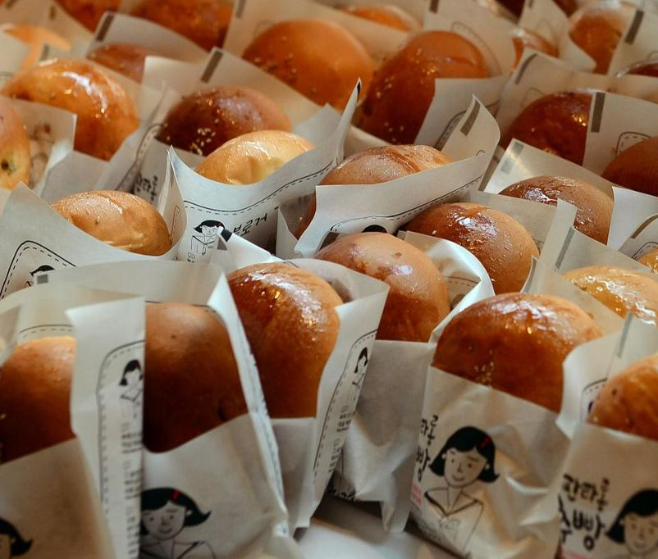 | How Daejeon evolved from 'boring city' to 'city of bread' Led by historic bakery Sungsimdang, Daejeon reshapes its own identity  - Have you been to Sungsimdang in Daejeon? Is it worth the journey?  - What else is there to do in Daejeon?  - Do you think Incheon is an exciting city?  - Where is your favorite travel destination in Korea?  - Do you have a favorite bakery? What do you usually buy?  - Have you ever baked your own bread?
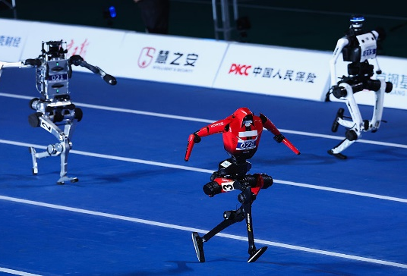 | Robots Smash Human Records at Beijing Competition  In a 100-meter sprint, a humanoid robot achieved a result of 9.39 seconds, beating the human record of 9.58 seconds set by Usain Bolt in 2009.  - Did you watch the Robot Games? Would you like to?  - Are you surprised that robots are breaking records?  - Would you rather watch humans or robots compete? Why?  - Are you more worried about robots or AI?  - Would you like to buy a robot from China? Why or why not?
 | Man thrown from Disco Pang Pang ride at Incheon amusement park  A man in his 30s was injured after being thrown from a “Disco Pang Pang” ride at an amusement park in Wolmido, Incheon.  - Have you ever been on the Disco Pang Pang? Was it fun?  - What is your favorite ride at the amusement park?  - What is the scariest ride you have ever tried?  - Do you trust amusement park rides?  - When was the last time you went to Wolmido?  - Which is better: Everland or Lotte World?
 | Seoul to crack down on overpriced hotel rates ahead of major fireworks festival  - Are you planning to watch the fireworks this year?  - Would you rather watch the fireworks or a drone show?  - Do hotels have a right to adjust their rates?  - Do you prefer to splurge or save on the hotel?  - Have you stayed in a unique or memorable hotel?  - When was the last time you watched a fireworks show?

