Headline News
Auguest 20, 2026
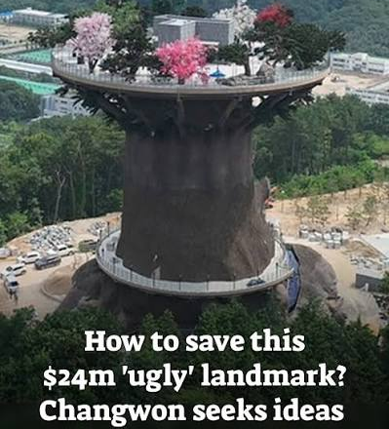 | Changwon asks public how to save its $24 million ‘ugly’ landmark  The contest, open to anyone in South Korea through Sept. 2, is seeking practical proposals to improve the Big Tree’s design, safety, convenience and potential uses.  - Do you agree that it is ugly?  - How would you fix it?  - Do you think that some things are so ugly that they are beautiful… like pugs?  - Have you ever been to Changwon? Would you like to go?  - How many world-famous landmarks have you visited? Which was your favorite?
 | Everland opens vote to name baby panda  Voters can select their favorite from: Ju Bao (“treasured jade”), Jun Bao (“outstanding treasure”), Lin Bao (“treasure precious as jade”), Yu Bao (“blessed treasure”) and Shu Bao (“dawn-bright treasure”).  - Will you vote?  - Which would you pick?  - Did you choose the name because of it’s meaning or because it sounds nice?  - Does your name have a meaning?  - Do you have panda fever?  - All giant pandas officially belong to China – how do you feel about this?  - When was the last time you went to Everland?
 | Drinking at Cheonggye Stream? It could cost you $70  Drinking, smoking, entering the water, cooking, sleeping outdoors, urinating and bringing pets to the stream area are already prohibited.  - Do you agree with all of these rules?  - Should people be allowed to put their feet in public fountains?  - When was the last time you went to Cheonggye Stream?  - Have you ever swum in a river or stream?  - Agree or disagree: Cheonggye Stream would be more interesting if you could float down the stream on a tube.
 | Generation Alpha  “Adults may not know this, but we spend a lot of time using AI. I think I probably spend more time talking to AI than to real people,” she said.Have you ever slept outside?  - What do you think about this statement?  - Are you more optimistic or pessimistic for Gen Alpha’s future?  - Many people are upset about the energy and water cost of using AI. What do you think?  - Did you use AI today? What for?

