Headline News
Auguest 13, 2026
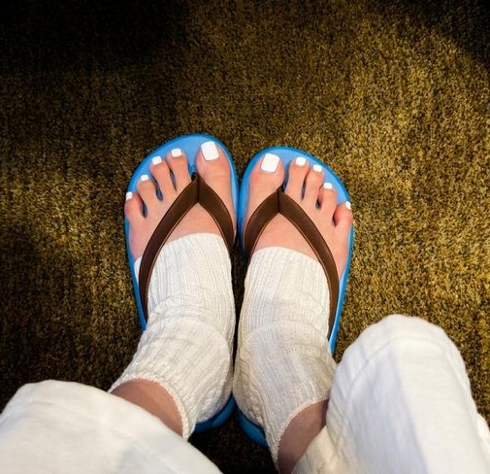 | 'Fashion disaster' flip-flops with socks become new summer trend among young Koreans  Open-toe socks designed for flip-flops are emerging as an unlikely fashion item.  - Do you wear socks with sandals? Why or why not?  - Would you like to try open-toe socks? What about glove socks?  - Do you prefer flip-flops or sandals?  - Which is more important: comfort or style?  - Do you pay attention to fashion trends?  - Do you prefer dressing up or dressing down?
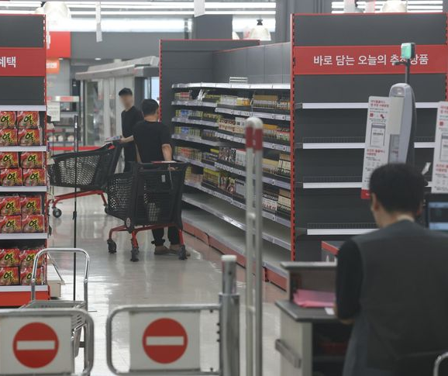 | Homeplus back in business  Retailer aims to restock shelves, win back customers after monthlong closure  - Are you happy to hear this news?  - Where do you usually buy groceries?  - Is it better to buy groceries online or in a store?  - Do you ever shop at a traditional market?  - Is it still a good idea that big supermarkets close every other Sunday?
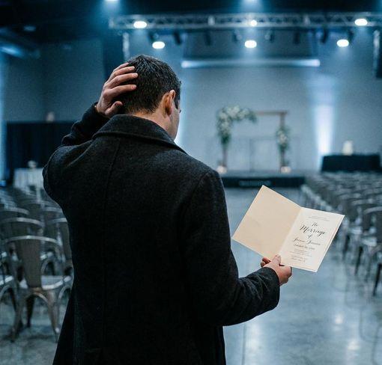 | School principal accused of faking married son's wedding for cash  When distributing the invitation, the principal said, "Because we are having a small wedding with just family, we are unable to invite guests." The notice nevertheless included bank account numbers for both the groom and bride to receive online transfers.  - Do you enjoy going to weddings?  - Would you send money without attending a wedding?  - Which is more important, the wedding or the honeymoon?  - What do you think about a wedding registry?  - How should this man be punished?
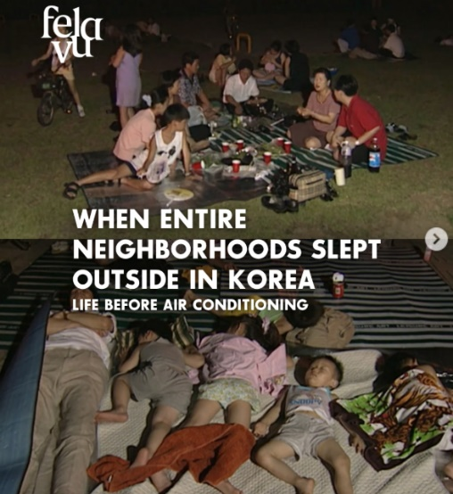 | When entire neighborhoods slept outside  Before air conditioning became common, entire neighborhoods in Korea would spend hot summer nights outside.  Families grabbed mats and mosquito coils, then headed to parks, riverbanks, and even quiet streets where the night breeze felt cooler.  - Have you ever slept outside?  - When was the last time you went camping?  - Can you sleep comfortably without air conditioning?  - Would you feel safe sleeping outside these days?  - Did you sleep well last night?

