Before watching:
Pick a word. Give a hint. Your partner guesses the word.
Eg: This is the name of an American city. It is also a mythical bird.
Radiator  Explorer  Attitude  Desert  Ocean | Salesman  Haunt  Dawn  Bitter  Creature | Ghost  Fault  Fantastical  Plymouth  Phoenix

How many can you answer:
- What kind of car are they driving?
- What city are they coming from?
- What do the men do for a living?
- What color are their ties?
- What color is the car?
- Who wakes up first?
- T or F – The young man takes off all of his clothes except his watch.

Discussion:
- Did you like this animation? Why or why not?
- What would you do if your car broke down in the middle of the desert?
- Is there a moral to this story?
- The older man says: It must have been nice back then, just swimming around carefree. Do you agree?
- Have you ever been to the desert / ocean / USA?
- Have you ever tried snorkeling or scuba diving?
- Can you swim?
- Are you afraid of the deep sea / sharks / jellyfish?
- Do you like fishing?
- Have you ever been in a car that broke down?
- Have you ever slept in a car?
- Is this animation similar to any movies that you’ve seen?
- Do you believe in ghosts?
- The Native Americans believed in a spirit animal. What is your spirit animal? https://www.spiritanimal.info/spirit-animal-quiz/
Script:
[COUNTRY BANJO MUSIC PLAYS]  [ENGINE SPLUTTERING]  ♪ And it's one step forward, baby Two steps back ♪  [CONTINUES ON RADIO] ♪ Two steps forward, baby ♪  ♪ Three steps back ♪ [WIND HOWLS]  Well?  Dead as our sales were last week.  Deader.  [CHUCKLES] Great.  Just fucking great.  Huh! Yeah, shit happens.  But somebody'll come along and give us a lift.  Nobody's gonna come down this cutoff.  Nobody, except idiots like us.  We never should have taken this road.  [SIGHS]  Radiator's done for.  Did you happen to check the water back in Phoenix like I asked?  Yes, and it was fine.  Well, if it was fine in Phoenix, then it wouldn't be dead now.  No, don't try and put this on me, old man.  You're all, "There's no stretch of this land I haven't been to, son."  Yeah, you're a real American explorer.  Shouldn't you be putting that in the radiator?  It's dead, son.  There's no coming back from dead.  Not even for a Plymouth.  Right.  So, what do we do?  [GROANS] We can rest the night here.  And just before dawn, when the weather's cooler, we start walking.  Walking?  All the way back to the last station?  Yep.  That's great. [SIGHS]  That's just... [SHOUTUNG] fucking great!  ♪ Down ♪  ♪ Don't you lay your body down ♪  ♪ Don't you lay your body ♪  ♪ Down ♪  ♪ Mm-hmm. ♪  [WIND HOWLING]  I'm sorry about earlier. It wasn't your fault.  I just get bitter sometimes.  The days of the door-to-door salesman are fadin' fast.  [CHUCKLING] Come on.  You know what I think?  It's all in the attitude.  The right attitude can sell anything.  Well, you certainly got plenty of that.  Reminds me of the sea.  Never seen the ocean.  Have to take your word for it.  Did you know that millions of years ago, this desert was a sea bottom?  All of this was water, full of fantastical creatures.  The world's an old place.  And for a long time, it was nothing but sea.  Nights like this, it gets me wonderin':  If the ghosts of people can haunt a house, well, why can't the ghosts of creatures haunt where they once lived?  [LAUGHS] I have no idea what the hell you're talking about.  [YAWNS] I'm gonna sleep in the back seat.  You can take the front.  It must have been nice back then.  Just swimming around without a care in the world.  [ELECTRICAL BUZZ]  [RADIO STATIC]  [WHALE SINGING]  What?  [GASPS]  -[WHISPERING] Wake up. -What?  Shhhh. Look.  YOUNGER MAN: Holy shit!  [LAUGHS] Wow!  You ever seen anything like this?  Never.  [YOUNGER MAN LAUGHS]  YOUNGER MAN: It's...  It's beautiful.  It must be something like you said.  Ghosts of an older world.  Boo!  [LAUGHS] Did you see that?  -Hey. -Oh, my God! [LAUGHS]  I can feel them!  [LAUGHS]  This is so cool.  Hey, hold on a second, boy.  [LAUGHS]  What are you doing?  [LAUGHS]  [SHOUTS] I'm going up there!  Synonyms for insane:  i_ _ _ _ _ / n_ _ _ / m_ _  [SHOUTS] Don't be crazy!  YOUNGER MAN: [SHOUTS] I wanna swim! [LAUGHS]  [CHUCKLES]  Hey, come back down here!  What?  [older man shouts] Hey!  Look, behind you! Look!  Hey! Look!  Goddamn ____ _____  Goddamn fool!  Look out!  Behind you!  Look!  [GASPS] | Give us a r___. A: ride  P___ us up. A: pick  Turnoff  I cut my finger. vs I cut off my finger.  That truck cut me off.  Please don’t cut me off when I’m talking.  The power company cut off my electricity.  My parents cut me off when I turned 25.  Put this on me = b____ A: blame  You’re all / You’re like… = You said  (eg: I was like… and he was all…)  Opposite of dawn = ____  It just dawned on me.  The dawn of civilization.  Opposite of bitter taste = ____  A bitter pill to swallow.  Till the bitter end.  I give you my word. =  Holy ____  holy crap, holy cow, holy mackerel, holy moly, , holy macaroni, holy smokes, holy f*@k
  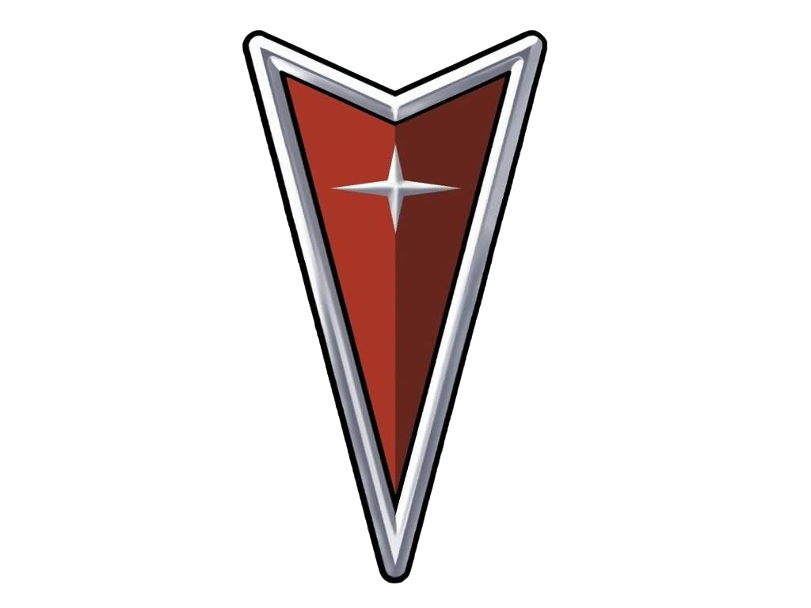 |  | 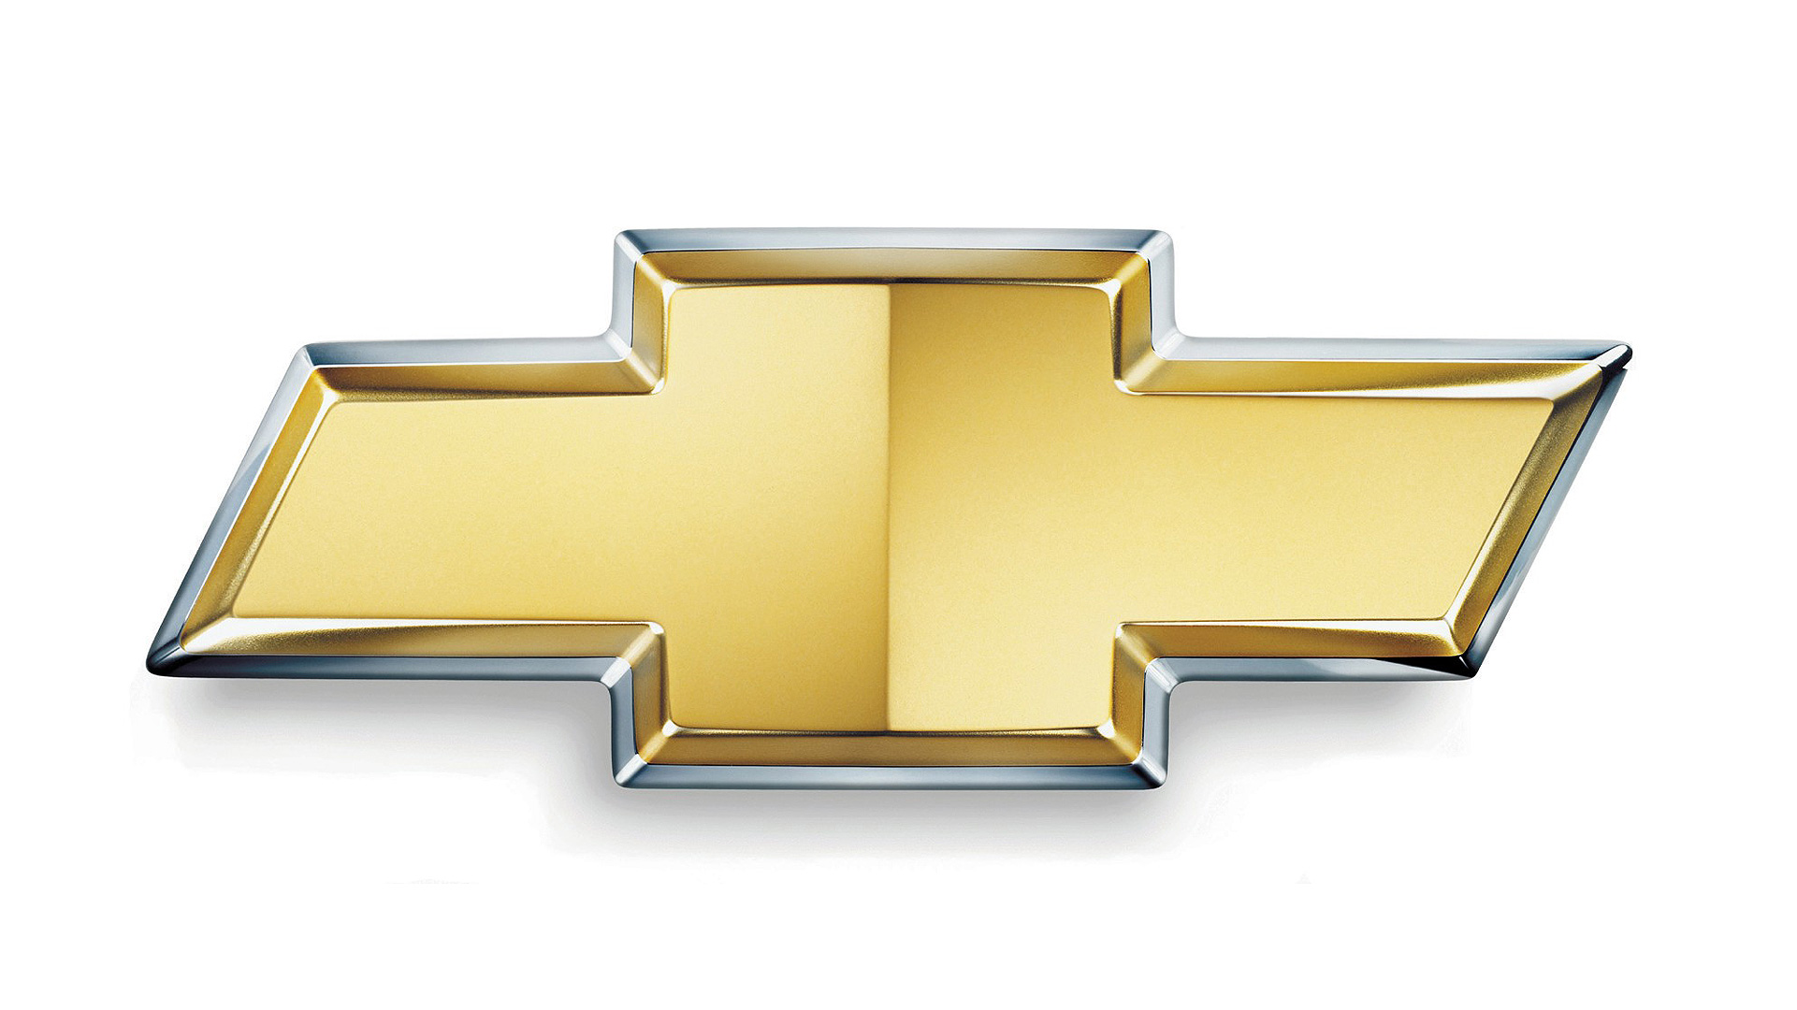

What does it mean? (Possible answers).
Both men died in the desert.
The older man was having a conversation with his younger self.
Sometimes it’s best not to get wrapped up in the past.
This is a different version of Icarus and The Sun.
I think that perhaps only the older man really exists, and the younger one is his younger self he's having some hallucination talking to and seeing swimming with the ghost fishes. The old man tells the young man about having seen the ocean before, that could just be him talking to his young self before that actually happened. I'm guessing that the old man is doing this sales trip by himself and he gets stuck in the dessert with the broken down car because he himself feels stuck in the job, stage in life, and reminisces about being young, dumb, carefree, and still curious.

You‘re The Wolf
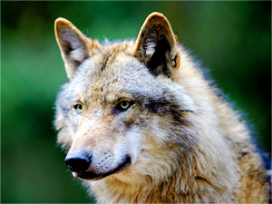

What It Means To Be The Wolf
The power of the wolf brings forth instinct, intelligence, appetite for freedom, and awareness of the importance of social connections. When the wolf shows up in your life, pay attention to what your intuition is telling you.

You‘re The Tiger
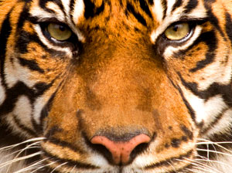

What It Means To Be The Tiger
In the kingdom of spirit animals, the tiger puts a special emphasis on raw feelings and emotions. The tiger spirit animal symbolizes primal instincts, unpredictability, and ability to trust yourself.

