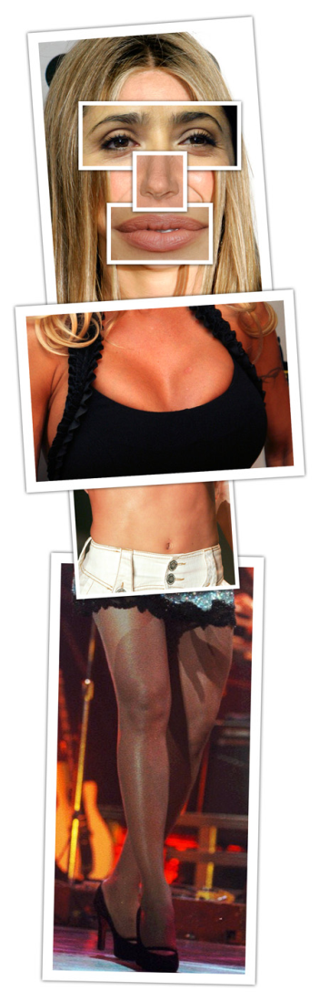
Dove Evolution
- Did you like this video? Why or why not?
- What is the message of this video?
- What are some pros and cons of looking like super model?
- What are some pros and cons of marrying a supermodel?
- Would you rather marry someone beautiful but poor, or rich but ugly?
- What do you think about plastic surgery? Is it helpful or harmful?
- If you could change one thing about yourself, what would you change?
- What is your ideal type?
- Who are some very attractive men/women?
- Which is more important, appearance or personality?
- “Beauty is in the eye of the beholder.” What do you think this means? Do you agree with it?
- “Beauty is only skin deep?” What do you think this means? Do you agree with it?
Finished? Ask your OWN questions.

