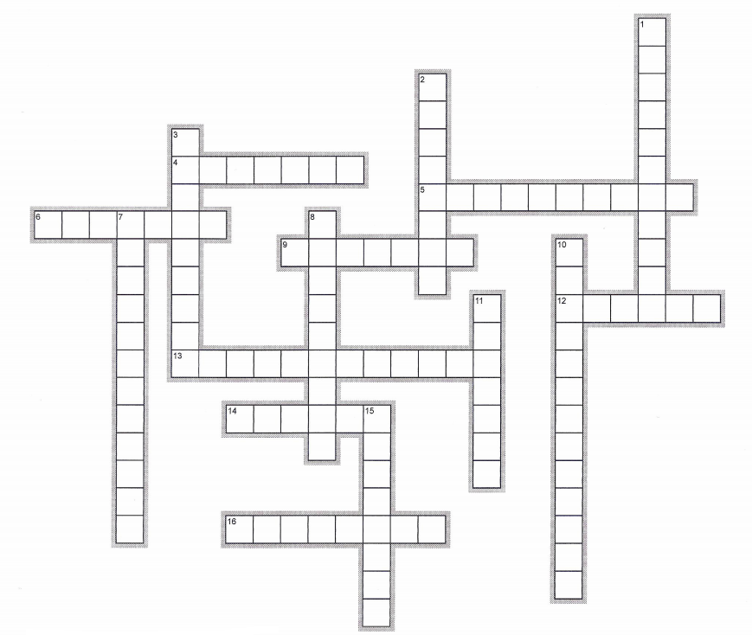
Week 12: Deviance and Crime (p165) + Who Commits Crime? (p172)

Across | Down
4. Stealing by violence or threat of violence  5. A collection of quantitative data  6. Not allowed by law  9. Things connected in complicated ways  12. Past tense of catch  13. The study of changes in large groups of people over time  14. Position or rank of someone when compared to others in a group  16. The act of killing another person | 1. Usually an activity associated with illegal drugs or firearms  2. The power of law to hold someone  3. Arranged or planned in a particular way  8. Consisting of or including large companies  10. Related to a combination of social and economic factors  11. A violent physical attack  15. Special or particular
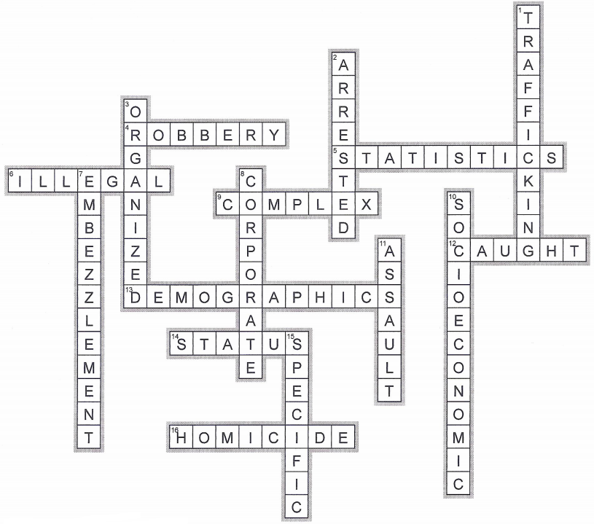
Week 12: Deviance and Crime (p165) + Who Commits Crime? (p172)

Across | Down
4. Stealing by violence or threat of violence  5. A collection of quantitative data  6. Not allowed by law  9. Things connected in complicated ways  12. Past tense of catch  13. The study of changes in large groups of people over time  14. Position or rank of someone when compared to others in a group  16. The act of killing another person | 1. Usually an activity associated with illegal drugs or firearms  2. The power of law to hold someone  3. Arranged or planned in a particular way  8. Consisting of or including large companies  10. Related to a combination of social and economic factors  11. A violent physical attack  15. Special or particular

