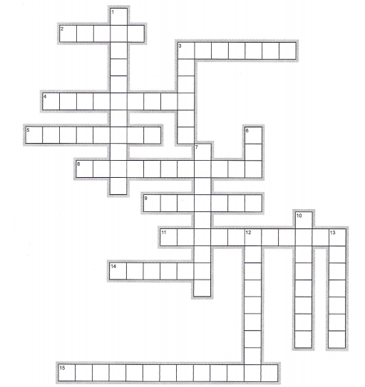
Week 11: Social Media + Learning and Thinking with New Media

Across | Down
2. types of websites for combining ideas  3. conforming to a type  4. to spread widely throughout a group or area  5. far from others  8. without giving a name  9. information such as text, video and sound  11. two-way flow of information  14. unverified information  15. the use of electronic communication to hurt or intimidate people | 1. to divide attention  3. a type of message limited to 140 characters  6. to give or bestow  7. to engage in more than one activity at the same time  10. the ability to read and write  12. to listen or observe closely  13. to improve
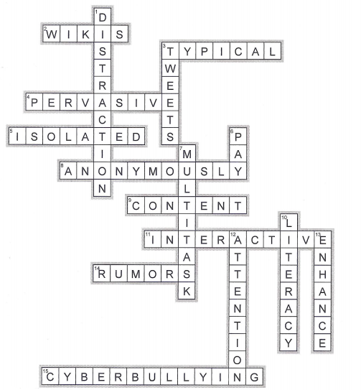
Week 11: Social Media + Learning and Thinking with New Media

Across | Down
2. types of websites for combining ideas  3. conforming to a type  4. to spread widely throughout a group or area  5. far from others  8. without giving a name  9. information such as text, video and sound  11. two-way flow of information  14. unverified information  15. the use of electronic communication to hurt or intimidate people | 1. to divide attention  3. a type of message limited to 140 characters  6. to give or bestow  7. to engage in more than one activity at the same time  10. the ability to read and write  12. to listen or observe closely  13. to improve

