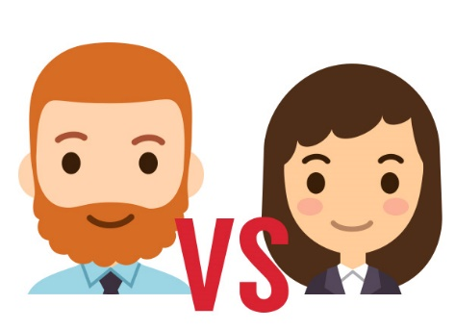
Who has it easier?
- Did you like this video? Why or why not?
- Name some advantages and disadvantages mentioned in the video?
- Who do you think has it easier? Why?
- Who has it easiest in your family?
- In your opinion how do women have it easier / harder?
- In your opinion how do men have it easier / harder?
- Are you going through any difficulties nowadays?
- What are some advantages that you’ve enjoyed?
Finished? Ask your OWN questions.

Who has it easier? (3:03): https://www.youtube.com/watch?v=paIueG9nRZU

