Mind Reader
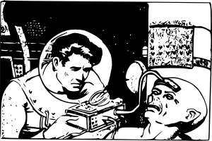
- Did you like the video?
- Do you use social media? Which sites?
- Would you be upset if a stranger was looking at your social media page?
- What kinds of things do you share online?
- Have you ever been to a fortune teller?
- Do you believe that some people can read minds?
- What could the man say about you if he looked at your social media page?
- How would you respond if this happened to you?
- Have you ever looked at someone else’s social media page?
- How often do you look at your ex’s page?
Finished? Ask your OWN questions.

Amazing Mind Reader (2:28): https://www.youtube.com/watch?v=F7pYHN9iC9I
OR
Social Media Experiment (3:42): https://www.youtube.com/watch?v=5P_0s1TYpJU

