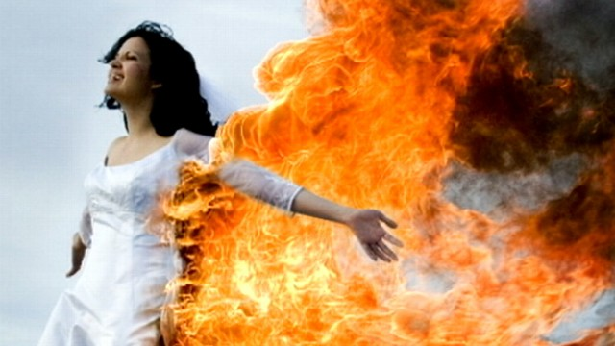
Hot Weddings
- Did you like this video? Why or why not?
- How many wedding ceremonies have you attended?
- Do you wish you could go to more weddings?
- Are weddings important?
- When would you like to get married?
- Where would you like to be married?
- What do you think you might like most/least about your wedding?
- Have you ever crashed a wedding? Would you like to?
- Would you like to have a fire at your wedding?
- Would you like to be a firefighter? Why or why not?
- Have you ever seen a building on fire?
- Why are some people fascinated with fire?
- Are you good at making a fire?
- “A child is not a vase to be filled but a fire to be lit.” What do you think of this quote?
Finished? Ask your OWN questions.

