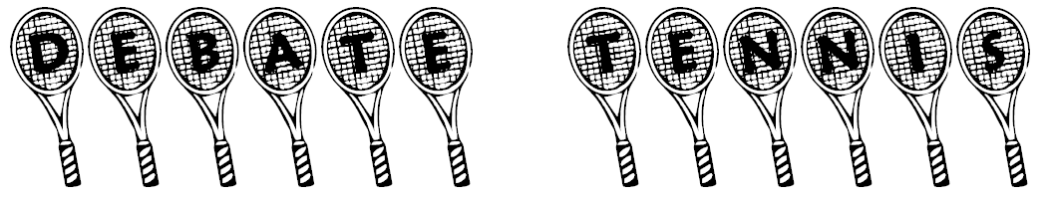
Instructions: Take turns giving reasons why your ‘thing’ is better than your partner’s ‘thing’. If your partner can’t think of another reason, you win the round!
Expressions: Yes, but… I see your point, but… You’re right, but… That’s true, but… You might be right, but… That’s not necessarily/always true…
Student A | Win? |  | Student B | Win?
living in the city |  | vs | living in the country
Gag Concert |  | vs | Running Man
Chun Ji Hyun |  | vs | Chun Won Ju
Won Bin |  | vs | Hyun Bin
beer |  | vs | soju
3D movies |  | vs | 2D movies
Chuseok |  | vs | Christmas
Taking a taxi |  | vs | Taking the bus
duk-bokie |  | vs | ramyeon
a trip to a mountain |  | vs | a trip to the sea
winter |  | vs | summer
classical music |  | vs | K-pop
screen golf |  | vs | real golf
having children |  | vs | having no children
Rain (Bi) |  | vs | Park Jin-Young
motorcycles |  | vs | cars

Example: A: Motorcycles are better than cars because they are fun to drive. B: That’s true, but cars are also fun to drive, and they are safer than motorcycles. A: You’re right, but motorcycles are cheaper than cars. B: That’s not necessarily true. Some motorcycles, such as Harley Davidsons, are more expensive than cars – and you can drive a car in the rain without getting wet. B: You’re right. You win.

Instructions: Take turns giving reasons why your ‘thing’ is better than your partner’s ‘thing’. If your partner can’t think of another reason, you win the round!
Expressions: Yes, but… I see your point, but… You’re right, but… That’s true, but… You might be right, but… That’s not necessarily/always true…
Student A | Win? |  | Student B | Win?
living in the city |  | vs | living in the country
Gag Concert |  | vs | Running Man
Chun Ji Hyun |  | vs | Chun Won Ju
Won Bin |  | vs | Hyun Bin
beer |  | vs | soju
3D movies |  | vs | 2D movies
Chuseok |  | vs | Christmas
Taking a taxi |  | vs | Taking the bus
duk-bokie |  | vs | ramyeon
a trip to a mountain |  | vs | a trip to the sea
winter |  | vs | summer
classical music |  | vs | K-pop
screen golf |  | vs | real golf
having children |  | vs | having no children
Rain (Bi) |  | vs | Park Jin-Young
motorcycles |  | vs | cars

Example: A: Motorcycles are better than cars because they are fun to drive. B: That’s true, but cars are also fun to drive, and they are safer than motorcycles. A: You’re right, but motorcycles are cheaper than cars. B: That’s not necessarily true. Some motorcycles, such as Harley Davidsons, are more expensive than cars – and you can drive a car in the rain without getting wet. B: You’re right. You win.

