Bicycle Skills
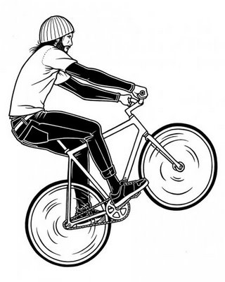
WHEELIE
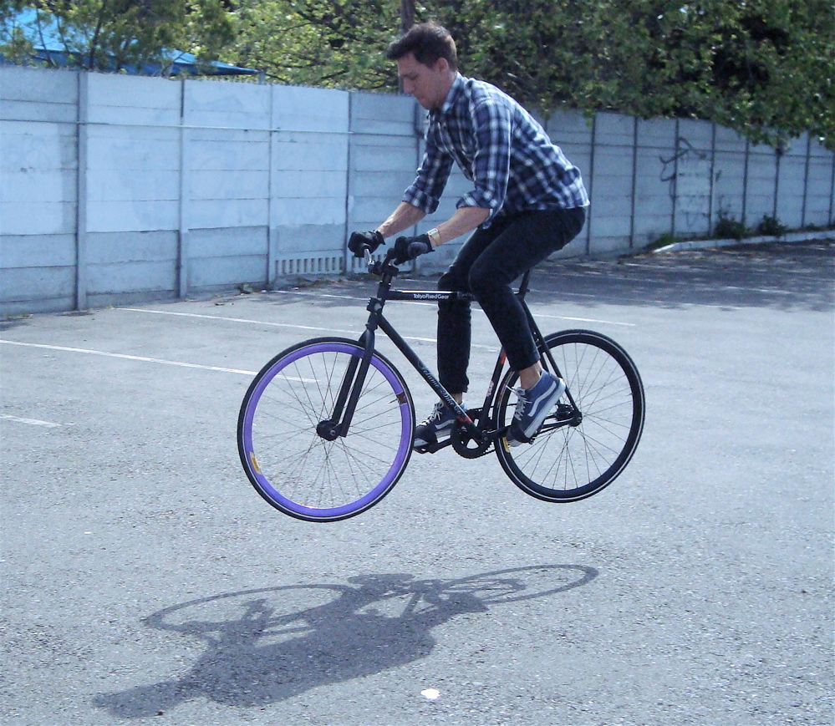
BUNNY HOP
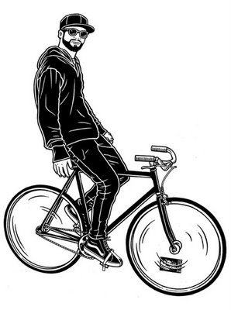
NO HANDS

- Did you like this video? Why or why not?
- Can you ride a bike? How often do you ride?
- Do you have a bike? What color is it?
- When is the last time you rode a bike? Where did you go?
- Have you ever tried mountain biking?
- Have you ever ridden a tricycle/unicycle/tandem bike?
- Where is the best place to ride a bike around here?
- If you go to the gym, do you prefer the stationary bike (exercise bike) or the treadmill (running machine)?
- Do you have good bicycle skills? Can you do a wheelie / bunny-hop / ride with no hands?
- What is your best skill? Eg: cooking, skiing, typing, juggling, gaming, sleeping, etc.
- Have you ever had a bicycle accident? What happened?
- Did you like the song in the video?
Finished? Ask your OWN questions. Eg: What’s your favorite sport?

Bicycle Skills – Danny Macaskill (5:37): http://www.youtube.com/watch?v=Z19zFlPah-o
Bonus Video:
Funny Old Man Riding Bicycle (1:13): https://www.youtube.com/watch?v=dSrsdjpVACA
Tiny Bike that Fits in a Backpack (0:21): https://www.youtube.com/watch?v=p8y0xpkdaNY

Bicycle Skills
WHEELIE
BUNNY HOP NO HANDS

- Did you like this video? Why or why not?
- Can you ride a bike? How often do you ride?
- Do you have a bike? What color is it?
- When is the last time you rode a bike? Where did you go?
- Have you ever tried mountain biking?
- Have you ever ridden a tricycle/unicycle/tandem bike?
- Where is the best place to ride a bike around here?
- If you go to the gym, do you prefer the stationary bike (exercise bike) or the treadmill (running machine)?
- Do you have good bicycle skills? Can you do a wheelie / bunny-hop / ride with no hands?
- What is your best skill? Eg: cooking, skiing, typing, juggling, gaming, sleeping, etc.
- Have you ever had a bicycle accident? What happened?
- Did you like the song in the video?
Finished? Ask your OWN questions. Eg: What’s your favorite sport?

WHEELIE
BUNNY HOP NO HANDS

Bicycle Skills
WHEELIE
BUNNY HOP NO HANDS

- Did you like this video? Why or why not?
- Can you ride a bike? How often do you ride?
- Do you have a bike? What color is it?
- When is the last time you rode a bike? Where did you go?
- Have you ever tried mountain biking?
- Have you ever ridden a tricycle/unicycle/tandem bike?
- Where is the best place to ride a bike around here?
- If you go to the gym, do you prefer the stationary bike (exercise bike) or the treadmill (running machine)?
- Do you have good bicycle skills? Can you do a wheelie / bunny-hop / ride with no hands?
- What is your best skill? Eg: cooking, skiing, typing, juggling, gaming, sleeping, etc.
- Have you ever had a bicycle accident? What happened?
- Did you like the song in the video?
Finished? Ask your OWN questions. Eg: What’s your favorite sport?

WHEELIE
BUNNY HOP NO HANDS

Bicycle Skills
WHEELIE
BUNNY HOP NO HANDS

- Did you like this video? Why or why not?
- Can you ride a bike? How often do you ride?
- Do you have a bike? What color is it?
- When is the last time you rode a bike? Where did you go?
- Have you ever tried mountain biking?
- Have you ever ridden a tricycle/unicycle/tandem bike?
- Where is the best place to ride a bike around here?
- If you go to the gym, do you prefer the stationary bike (exercise bike) or the treadmill (running machine)?
- Do you have good bicycle skills? Can you do a wheelie / bunny-hop / ride with no hands?
- What is your best skill? Eg: cooking, skiing, typing, juggling, gaming, sleeping, etc.
- Have you ever had a bicycle accident? What happened?
- Did you like the song in the video?
Finished? Ask your OWN questions. Eg: What’s your favorite sport?

