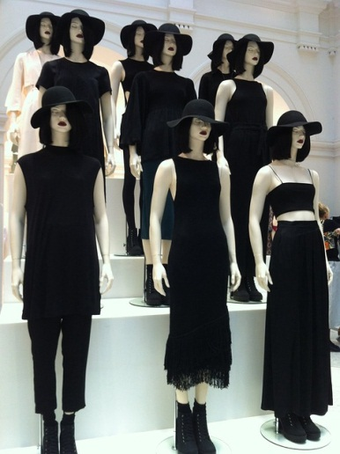
Conformity
- Did you like this video? Why or why not?
- How would you behave in this situation?
- Do you think conforming is generally good or bad?
- Do you conform to trends in fashion / music / technology?
- What are some trends these days that you dislike?
- In what ways do you try to be unique?
- Have you ever broken the rules at school / home?
- Have you ever felt peer pressure? When?
- If all your friends were doing it, would you get a tattoo / shave your head / jump off a bridge / buy a motorcycle / get drunk?
- Would you rather be the same or different from everyone. Why?
- Are you more of a leader or follower? Why do you think so?
Finished? Ask your OWN questions.

Social Conformity - Brain Games (3:39): https://www.youtube.com/watch?v=o8BkzvP19v4

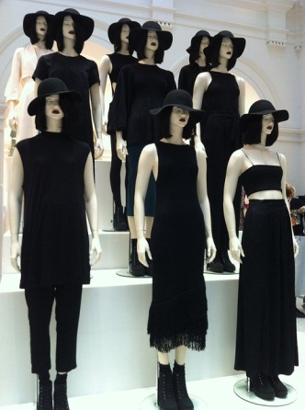
Conformity
- Did you like this video? Why or why not?
- How would you behave in this situation?
- Do you think conforming is generally good or bad?
- Do you conform to trends in fashion / music / technology?
- What are some trends these days that you dislike?
- In what ways do you try to be unique?
- Have you ever broken the rules at school / home?
- Have you ever felt peer pressure? When?
- If all your friends were doing it, would you get a tattoo / shave your head / jump off a bridge / buy a motorcycle / get drunk?
- Would you rather be the same or different from everyone. Why?
- Are you more of a leader or follower? Why do you think so?
Finished? Ask your OWN questions.
Conformity
- Did you like this video? Why or why not?
- How would you behave in this situation?
- Do you think conforming is generally good or bad?
- Do you conform to trends in fashion / music / technology?
- What are some trends these days that you dislike?
- In what ways do you try to be unique?
- Have you ever broken the rules at school / home?
- Have you ever felt peer pressure? When?
- If all your friends were doing it, would you get a tattoo / shave your head / jump off a bridge / buy a motorcycle / get drunk?
- Would you rather be the same or different from everyone. Why?
- Are you more of a leader or follower? Why do you think so?
Finished? Ask your OWN questions.
Conformity
- Did you like this video? Why or why not?
- How would you behave in this situation?
- Do you think conforming is generally good or bad?
- Do you conform to trends in fashion / music / technology?
- What are some trends these days that you dislike?
- In what ways do you try to be unique?
- Have you ever broken the rules at school / home?
- Have you ever felt peer pressure? When?
- If all your friends were doing it, would you get a tattoo / shave your head / jump off a bridge / buy a motorcycle / get drunk?
- Would you rather be the same or different from everyone. Why?
- Are you more of a leader or follower? Why do you think so?
Finished? Ask your OWN questions.

