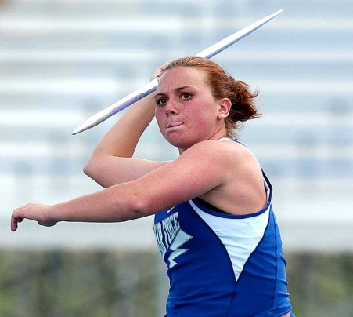
Throw like a Girl
- Did you like this video? Why or why not?
- Do you throw like a girl?
- Is it an insult to say “you throw like a girl”? Why do you think so?
- What is your favorite sport that involves throwing?
- Do guys and girls throw differently? If so, is the reason due to genetics or socialization?
- Which sports are more interesting with female athletes? Why?
- Which sports are more interesting with male athletes? Why?
- Is it harder to be a man or a woman?
- Is it OK if men and women behave differently? What do you consider to be typical female / male behavior?
- When is the last time you threw something? What was it?
- Have you ever thrown a party?
Finished? Ask your OWN questions.

Always #LikeAGirl (3:18): https://www.youtube.com/watch?v=XjJQBjWYDTs

