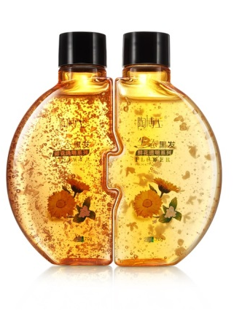
Shampoo Prank
- Did you like this video? Why or why not?
- Was this prank funny or mean?
- Do you prefer taking a bath or a shower?
- Do you sing in the shower?
- What brand of shampoo do you use?
- Do you prefer liquid soap or bar soap? Why?
- Do you prefer taking a shower in the morning or evening? Why?
- Have you ever pranked someone? How?
- Do you like going to a sauna (찜질방) or public bath (목욕탕)?
- Do you usually take quick or long showers / baths?
- What is your morning routine? (eg: First, check my phone. Then eat breakfast…etc.)
- Do you use different soaps or lotions for your hands, body and face?
Finished? Ask your OWN questions.

Shampoo Prank (3:34): https://www.youtube.com/watch?v=SqBP0SDtwvg

