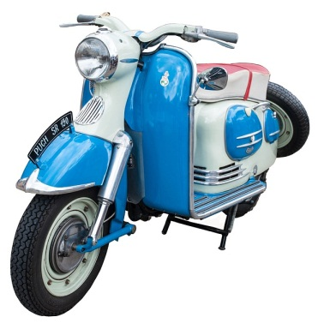
Freestyle Scooter Tricks
- Did you like this video? Why or why not?
- Do you think the man is cool or crazy?
- Do you like motorcycles? Why or why not?
- Have you ever ridden a motorcycle?
- Would you like to have a scooter? Why or why not?
- Do you prefer scooters, sports bikes, or cruisers?
- Should motorcyclists be allowed to lane split (go between cars)?
- Should motorcyclists be allowed on highways? Why or why not?
- What are some advantages and disadvantages of using a motorcycle?
- Can you do any tricks on a motorcycle / bicycle / car?
- Do you have a driver’s license?
- Have you ever gotten a ticket or been pulled over by the police?
- Should helmets by mandatory for motorcyclists / bicyclists? Why?
Finished? Ask your OWN questions.

Freestyle Scooter Tricks (2:49): https://www.youtube.com/watch?v=rBkmZNyd93o
Bonus Video:
Old Man Chilling on his Motorcycle (0:41): https://www.youtube.com/watch?v=-wHeSBWYrkg
Motorcycle stunts Martin & Kate (3:17): https://www.youtube.com/watch?v=ZhHK-5B6ZNY

Freestyle Scooter Tricks
- Did you like this video? Why or why not?
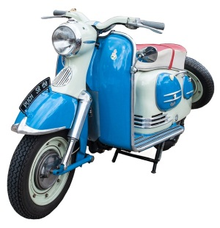
- Do you think the man is cool or crazy?
- Do you like motorcycles? Why or why not?
- Have you ever ridden a motorcycle?
- Would you like to have a scooter? Why or why not?
- Do you prefer scooters, sports bikes, or cruisers?
- Should motorcyclists be allowed to lane split (go between cars)?
- Should motorcyclists be allowed on highways? Why or why not?
- What are some advantages and disadvantages of using a motorcycle?
- Can you do any tricks on a motorcycle / bicycle / car?
- Do you have a driver’s license?
- Have you ever gotten a ticket or been pulled over by the police?
- Should helmets by mandatory for motorcyclists / bicyclists? Why? Finished? Ask your OWN questions.

Freestyle Scooter Tricks
- Did you like this video? Why or why not?
- Do you think the man is cool or crazy?
- Do you like motorcycles? Why or why not?
- Have you ever ridden a motorcycle?
- Would you like to have a scooter? Why or why not?
- Do you prefer scooters, sports bikes, or cruisers?
- Should motorcyclists be allowed to lane split (go between cars)?
- Should motorcyclists be allowed on highways? Why or why not?
- What are some advantages and disadvantages of using a motorcycle?
- Can you do any tricks on a motorcycle / bicycle / car?
- Do you have a driver’s license?
- Have you ever gotten a ticket or been pulled over by the police?
- Should helmets by mandatory for motorcyclists / bicyclists? Why? Finished? Ask your OWN questions.

Freestyle Scooter Tricks
- Did you like this video? Why or why not?
- Do you think the man is cool or crazy?
- Do you like motorcycles? Why or why not?
- Have you ever ridden a motorcycle?
- Would you like to have a scooter? Why or why not?
- Do you prefer scooters, sports bikes, or cruisers?
- Should motorcyclists be allowed to lane split (go between cars)?
- Should motorcyclists be allowed on highways? Why or why not?
- What are some advantages and disadvantages of using a motorcycle?
- Can you do any tricks on a motorcycle / bicycle / car?
- Do you have a driver’s license?
- Have you ever gotten a ticket or been pulled over by the police?
- Should helmets by mandatory for motorcyclists / bicyclists? Why? Finished? Ask your OWN questions.

