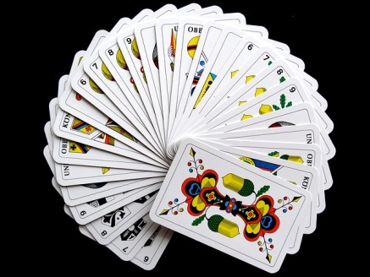
Cardistry
- Did you like this video? Why or why not?
- How often do you play cards?
- How many card games can you name?
- When is the last time you played a board game?
- How many games do you have on your phone?
- Do you like games? Why or why not?
- What is your favorite card game / board game / video game?
- Do you think games are good or bad for children? Why?
- At what age should people be allowed to play violent video games?
- Do you like gambling? Have you ever been to a casino?
- Should gambling be illegal? Why or why not?
- Can you juggle?
- What is your hidden talent?
Finished? Ask your OWN questions.

Cardistry – Virtuoso: Liquid Paper (3:21): https://www.youtube.com/watch?v=I0KSaqiv5C0
Bonus Video:
Floating Cards (1:27): https://www.youtube.com/watch?v=NObQp8r4Wzg
Alternate Videos:
Cardistry – Virtuoso: Air Time (1:00): https://www.youtube.com/watch?v=iWq5n_8mrfU
Hypnotic Cardistry Kid (3:03): https://www.youtube.com/watch?v=qfOwe6Ronb8
Five-Time World Champion (4:34): https://www.youtube.com/watch?v=hGlH8g09diY
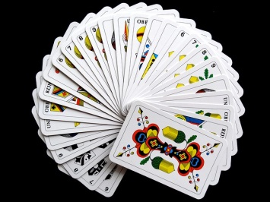
Cardistry
- Did you like this video? Why or why not?
- How often do you play cards?
- How many card games can you name?
- When is the last time you played a board game?
- How many games do you have on your phone?
- Do you like games? Why or why not?
- What is your favorite card game / board game / video game?
- Do you think games are good or bad for children? Why?
- At what age should people be allowed to play violent video games?
- Do you like gambling? Have you ever been to a casino?
- Should gambling be illegal? Why or why not?
- Can you juggle?
- What is your hidden talent? Finished? Ask your OWN questions.

Cardistry
- Did you like this video? Why or why not?
- How often do you play cards?
- How many card games can you name?
- When is the last time you played a board game?
- How many games do you have on your phone?
- Do you like games? Why or why not?
- What is your favorite card game / board game / video game?
- Do you think games are good or bad for children? Why?
- At what age should people be allowed to play violent video games?
- Do you like gambling? Have you ever been to a casino?
- Should gambling be illegal? Why or why not?
- Can you juggle?
- What is your hidden talent? Finished? Ask your OWN questions.

Cardistry
- Did you like this video? Why or why not?
- How often do you play cards?
- How many card games can you name?
- When is the last time you played a board game?
- How many games do you have on your phone?
- Do you like games? Why or why not?
- What is your favorite card game / board game / video game?
- Do you think games are good or bad for children? Why?
- At what age should people be allowed to play violent video games?
- Do you like gambling? Have you ever been to a casino?
- Should gambling be illegal? Why or why not?
- Can you juggle?
- What is your hidden talent? Finished? Ask your OWN questions.

