Man vs. Wild – Beetle Larva
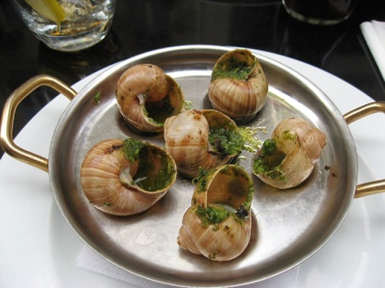
- Did you like this video? Why or why not?
- What is the strangest thing you’ve ever eaten?
- Have you ever eaten a bug?
- Are you a picky eater or an adventurous eater?
- Do you think you could survive in the jungle?
- What’s your favorite / least favorite food?
- What did you eat today / yesterday?
- What are some things that you can cook well?
- Where is your favorite restaurant?
- How do you usually eat dinner? (eg: in front of the TV, computer, at the table with family, etc.)
- Do you eat at regular or irregular times?
- Is breakfast really the most important meal of the day? Why?
- How often do you have a midnight snack?
- Which countries have the best food?
Finished? Ask your OWN questions.

Beetle Larva (2:07): http://www.youtube.com/watch?v=QuB3kr3ckYE
Bonus Video:
Just Eat It (1:27): http://www.youtube.com/watch?v=qSw7uwx3Mrc
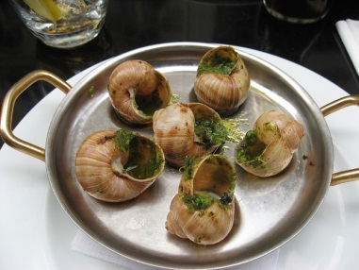
Man vs. Wild – Beetle Larva
- Did you like this video? Why or why not?
- What is the strangest thing you’ve ever eaten?
- Have you ever eaten a bug?
- Are you a picky eater or an adventurous eater?
- Do you think you could survive in the jungle?
- What’s your favorite / least favorite food?
- What did you eat today / yesterday?
- What are some things that you can cook well?
- Where is your favorite restaurant?
- How do you usually eat dinner? (eg: in front of the TV, computer, at the table with family, etc.)
- Do you eat at regular or irregular times?
- Is breakfast really the most important meal of the day? Why?
- How often do you have a midnight snack?
- Which countries have the best food? Finished? Ask your OWN questions.

Man vs. Wild – Beetle Larva
- Did you like this video? Why or why not?
- What is the strangest thing you’ve ever eaten?
- Have you ever eaten a bug?
- Are you a picky eater or an adventurous eater?
- Do you think you could survive in the jungle?
- What’s your favorite / least favorite food?
- What did you eat today / yesterday?
- What are some things that you can cook well?
- Where is your favorite restaurant?
- How do you usually eat dinner? (eg: in front of the TV, computer, at the table with family, etc.)
- Do you eat at regular or irregular times?
- Is breakfast really the most important meal of the day? Why?
- How often do you have a midnight snack?
- Which countries have the best food? Finished? Ask your OWN questions.

Man vs. Wild – Beetle Larva
- Did you like this video? Why or why not?
- What is the strangest thing you’ve ever eaten?
- Have you ever eaten a bug?
- Are you a picky eater or an adventurous eater?
- Do you think you could survive in the jungle?
- What’s your favorite / least favorite food?
- What did you eat today / yesterday?
- What are some things that you can cook well?
- Where is your favorite restaurant?
- How do you usually eat dinner? (eg: in front of the TV, computer, at the table with family, etc.)
- Do you eat at regular or irregular times?
- Is breakfast really the most important meal of the day? Why?
- How often do you have a midnight snack?
- Which countries have the best food? Finished? Ask your OWN questions.

