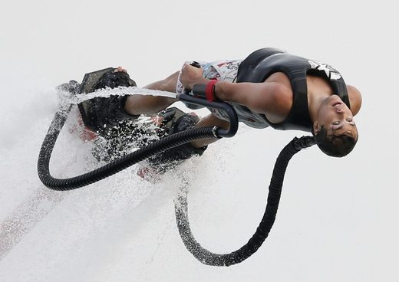
Flyboard + Aqua Skipper
- Did you like these videos? Why or why not?
- Which video did you like better?
- Would you rather try the ‘Flyboard’ or the ‘Aqua Skipper? Why?
- What water sports have you tried? Which are your favorite? Eg: water skiing, snorkeling, etc.
- How many different water sports can you think of?
- Are you a good swimmer? Have you ever taken lessons?
- Are you afraid of the water? Are you afraid of sharks?
- Do you think the ‘Flyboard’ company will be a success? What about the ‘Aqua Skipper’? Which will be more successful?
- What are your plans for summer vacation?
- Did you like the music in these videos? Which song was better?
- When is the last time you went to the beach? Tell me about it.
Finished? Ask your OWN questions.

Flyboard (3:17): http://www.youtube.com/watch?v=m4Bm3cs9TFo
Aqua Skipper (0:49): http://www.youtube.com/watch?v=PfxRtwtPJ9A

Flyboard + Aqua Skipper
- Did you like these videos? Why or why not?
- Which video did you like better?
- Would you rather try the ‘Flyboard’ or the ‘Aqua Skipper? Why?
- What water sports have you tried? Which are your favorite? Eg: water skiing, snorkeling, etc.
- How many different water sports can you think of?
- Are you a good swimmer? Have you ever taken lessons?
- Are you afraid of the water? Are you afraid of sharks?
- Do you think the ‘Flyboard’ company will be a success? What about the ‘Aqua Skipper’? Which will be more successful?
- What are your plans for summer vacation?
- Did you like the music in these videos? Which song was better?
- When is the last time you went to the beach? Tell me about it.
Finished? Ask your OWN questions.

Flyboard + Aqua Skipper
- Did you like these videos? Why or why not?
- Which video did you like better?
- Would you rather try the ‘Flyboard’ or the ‘Aqua Skipper? Why?
- What water sports have you tried? Which are your favorite? Eg: water skiing, snorkeling, etc.
- How many different water sports can you think of?
- Are you a good swimmer? Have you ever taken lessons?
- Are you afraid of the water? Are you afraid of sharks?
- Do you think the ‘Flyboard’ company will be a success? What about the ‘Aqua Skipper’? Which will be more successful?
- What are your plans for summer vacation?
- Did you like the music in these videos? Which song was better?
- When is the last time you went to the beach? Tell me about it.
Finished? Ask your OWN questions.

Flyboard + Aqua Skipper
- Did you like these videos? Why or why not?
- Which video did you like better?
- Would you rather try the ‘Flyboard’ or the ‘Aqua Skipper? Why?
- What water sports have you tried? Which are your favorite? Eg: water skiing, snorkeling, etc.
- How many different water sports can you think of?
- Are you a good swimmer? Have you ever taken lessons?
- Are you afraid of the water? Are you afraid of sharks?
- Do you think the ‘Flyboard’ company will be a success? What about the ‘Aqua Skipper’? Which will be more successful?
- What are your plans for summer vacation?
- Did you like the music in these videos? Which song was better?
- When is the last time you went to the beach? Tell me about it.
Finished? Ask your OWN questions.
PRINT

