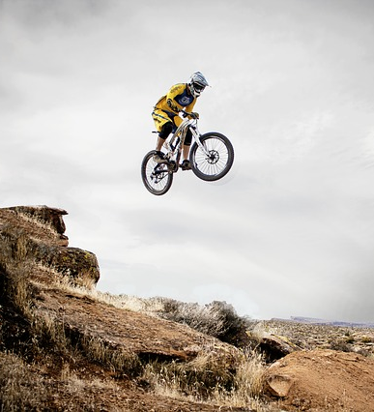
Red Bull Rampage
- Did you like this video? Why or why not?
- Can you ride a bike? How often do you ride?
- Do you have a bike? Describe it.
- Would you rather have a road bike or a mountain bike? Why?
- Would you rather ride on a mountain trail or a bike path?
- Have you ever tried mountain biking? Would you like to?
- When is the last time you rode a bike? Where did you go?
- Have you ever been to Utah? Have you ever been to a desert?
- Do you think the men are cool or crazy?
- Would you ride down that trail for $1,000,000 (1 million dollars)?
- Are you the type of person who takes a risk or plays it safe?
- It’s better to be safe than sorry. Do you agree?
Finished? Ask your OWN questions.

Red Bull Rampage (2:03): https://www.youtube.com/watch?v=C_h1Cgv4K2c
Bonus Video:
Cam Zink Rampage crash (0:45): https://www.youtube.com/watch?v=W2YHMMgQwIc
Cam Zink Rampage crash (another view) (0:26) https://www.youtube.com/watch?v=r4Trp3sMmU4

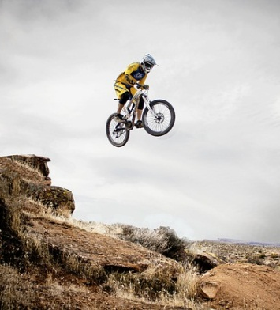
Red Bull Rampage
- Did you like this video? Why or why not?
- Can you ride a bike? How often do you ride?
- Do you have a bike? Describe it.
- Would you rather have a road bike or a mountain bike? Why?
- Would you rather ride on a mountain trail or a bike path?
- Have you ever tried mountain biking? Would you like to?
- When is the last time you rode a bike? Where did you go?
- Have you ever been to Utah? Have you ever been to a desert?
- Do you think the men are cool or crazy?
- Would you ride down that trail for $1,000,000 (1 million dollars)?
- Are you the type of person who takes a risk or plays it safe?
- It’s better to be safe than sorry. Do you agree?
Finished? Ask your OWN questions.

Red Bull Rampage
- Did you like this video? Why or why not?
- Can you ride a bike? How often do you ride?
- Do you have a bike? Describe it.
- Would you rather have a road bike or a mountain bike? Why?
- Would you rather ride on a mountain trail or a bike path?
- Have you ever tried mountain biking? Would you like to?
- When is the last time you rode a bike? Where did you go?
- Have you ever been to Utah? Have you ever been to a desert?
- Do you think the men are cool or crazy?
- Would you ride down that trail for $1,000,000 (1 million dollars)?
- Are you the type of person who takes a risk or plays it safe?
- It’s better to be safe than sorry. Do you agree?
Finished? Ask your OWN questions.

Red Bull Rampage
- Did you like this video? Why or why not?
- Can you ride a bike? How often do you ride?
- Do you have a bike? Describe it.
- Would you rather have a road bike or a mountain bike? Why?
- Would you rather ride on a mountain trail or a bike path?
- Have you ever tried mountain biking? Would you like to?
- When is the last time you rode a bike? Where did you go?
- Have you ever been to Utah? Have you ever been to a desert?
- Do you think the men are cool or crazy?
- Would you ride down that trail for $1,000,000 (1 million dollars)?
- Are you the type of person who takes a risk or plays it safe?
- It’s better to be safe than sorry. Do you agree?
Finished? Ask your OWN questions.

