

 | - Chickens can live for several month without a head.  - Have you ever killed a chicken?  - Have you ever seen a chicken killed?  - Do you prefer chicken, beef, or pork?  - Where is your favorite chicken restaurant? | □ Fact  □ Fiction
 | B) The distance between the earth and the sun is what makes the seasons.  - What’s your favorite season? Why?  - What’s your favorite planet? Why?  - Are you interested in astronomy or astrology?  - What’s your birth sign? Does your personality match your birth sign? | □ Fact  □ Fiction
 | C) A penny dropped from the top of a tall building could kill a pedestrian.  - Are you afraid of heights?  - Have you been to the top of a very tall tower or building? Where?  - What floor do you live on? Do you like it?  - Have you ever been hit in the head? What happened? | □ Fact  □ Fiction

Fold here

A) When a chicken’s head is cut off, often the lower part of the brain isn’t cut. The lower part of the brain is called the brain stem. The brain stem controls most of the chicken’s reflexes, so it can still run around, even without its head. Most chickens will only live for a few minutes but one famous chicken, named Mike, lived eighteen months without a head! His owner kept him alive by dropping milk and water down his open esophagus.

B) The distance between the earth and the sun actually has very little effect on temperature and seasons. If distance made a big difference, then countries like Indonesia and Ecuador would have cold winters too. It's the angle of the earth's tilt – toward the sun in the summer for the Northern Hemisphere and away in the winter – that makes the seasons.

C) A penny doesn’t have a very aerodynamic shape. That means the shape of a penny makes it fall more slowly. If a penny were dropped from the 381 meter high Empire State Building, it would only travel fast enough to cause a little pain to the unlucky person it hit.

Photo 1 by kuhnmi, Photo 2 by joiseyshowaa, Photo 3 by Hernán Piñera. All photos CC BY.
1

 | A) Animals can predict natural disasters.  - Do you have any pets?  - What’s your favorite animal? Why?  - Are you good at predicting the future?  - Do you believe in fortune-telling?  - Have you ever experienced a natural disaster? | □ Fact  □ Fiction
 | B) Water drains backwards in the Southern Hemisphere due to the Earth's rotation.  - Do you know which direction water drains in your home?  - Have you ever been to the Southern Hemisphere?  - Would you rather visit the North or South pole? Why? | □ Fact  □ Fiction
 | C) Adults don't grow new brain cells.  - Do you do any brain exercises?  - Do you have a good memory?  - Do you enjoy trivia games?  - Are you learning anything new these days? | □ Fact  □ Fiction

Fold here

A) There is no evidence that animals possess a mysterious sixth-sense allowing them to predict natural disasters. Their keen senses of smell, hearing, and sharp instincts alone are enough to send them scattering for the hillsides during a hurricane or tsunami. And even so, animals often die during natural disasters, so if they do have some sort of sixth sense, it's not worth much.

B) In principle, the Coriolis effect would cause water to drain clockwise in the Northern hemisphere and counterclockwise in the Southern hemisphere. However, in reality, the small irregularities in your sink and tub have a much bigger effect than the Earth’s rotation. Tests that you can easily perform in a few washrooms will show that water spins in both directions depending on the sink’s structure, not the hemisphere.

C) Much of a human's crucial brain development happens during childhood, but it isn't all downhill from there. Studies have shown that neurons continue to grow and change well into the adult years.

2
Photo 1 by germanny, Photo 2 by Ignacio Sanz, Photo 3 by Gerry Shaw. All photos CC BY.

 | A) Humans use only 10% of their brains.  - Do you like to study? How often do you study?  - What’s your favorite subject?  - Do you exercise your brain? How?  - What percentage of your brain do you use?  - Do believe it’s possible to move objects with the mind? (telekinesis) | □ Fact  □ Fiction
 | B) The Great Wall of China is the only man-made structure visible from space.  - Have you ever been to China?  - Would you like to travel into space? Why or why not?  - Which is more impressive: the great wall, or the pyramids?  - Where is the most impressive place that you’ve visited? | □ Fact  □ Fiction
 | C) It takes seven years to digest gum.  - How often do you chew gum?  - Do you have a favorite brand or flavor of gum?  - What do you do with gum when you are finished?  - Have you ever swallowed gum?  - Have you ever chewed an old piece of gum?  - Have you ever chewed someone else’s gum? | □ Fact  □ Fiction

Fold here

A) This media darling has been around for at least a century. Fortunately, it's just not true. MRI imaging clearly demonstrates--with fancy colors no less--that humans put most of their cerebral cortex to good use, even while dozing.

B) There are several variations on this folkloric statement, and they're all quantifiably false. Astronauts can spot the Great Wall from low-Earth orbit, along with plenty of other things like the Giza pyramids and even airport runways. But they can't see the Wall from the Moon.

C) While it may prove a bit more difficult to break down than organic foodstuffs, chewing gum gets no special treatment from the digestive system. Doctors figure this old wives' tale was invented to prevent kids from swallowing the rubbery substance.

3
Photo 1 by digitalbob8 / CC BY, Photo 2 by NASA / Public Domain, Photo 3 by Purple Sherbet Photography / CC BY.

 | A) Hair and fingernails continue growing after death.  - How often do you get a haircut?  - Do you bite your fingernails?  - Have you ever had a manicure or a pedicure?  - Would you shave your head if someone paid you? | □ Fact  □ Fiction
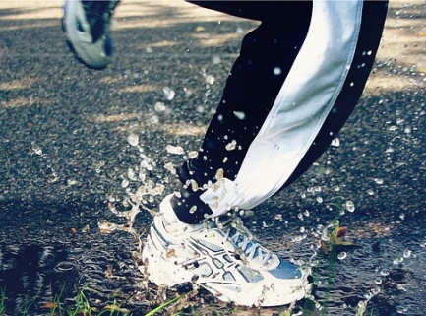 | B) You get less wet by running in the rain.  - Do you like rainy days? Why or why not?  - What are some activities for a rainy day?  - What color is your umbrella? | □ Fact  □ Fiction
 | C) Chicken soup can help cure the common cold.  - Do you like soup? What’s your favorite kind?  - How often do you catch a cold?  - Do you have a good home remedy for a cold? | □ Fact  □ Fiction

Fold here

A) Though hair and fingernails appear to keep growing after death, this is merely a morbid optical illusion at work. In death the human body dehydrates severely, retracting enough skin to expose more nail and hair.

B) Actual mathematical equations devoted to this popular question have suggested it is true, though not for the simple reasons you might think. Complexities include factoring in the number of rain drops hitting the walker's head versus smacking the runner's chest.

C) While there is no cure for the common cold, science suggests that moms around the world are right in forcing spoonfuls of hot chicken soup down their sick kids’ throats. Studies have found that the broth actually contains anti-inflammatory properties that help reduce congestion. In fact, any warm liquid will help loosen congestion as well as prevent dehydration.

4
Photo 1 by r e n a t a / CC BY, Photo 2 by bertvthul / Public Domain, Photo 3 by bykst / Public Domain

 | A) There is no gravity in space.  - Would you like to be a space tourist?  - Should the government spend money on space exploration?  - Are you interested in astronomy?  - Are you interested in astrology?  - Do you believe we will ever make contact with aliens? | □ Fact  □ Fiction
 | B) Yawning is "contagious".  - Do you enjoy yawning?  - Do you feel like yawing now?  - What time do you usually go to sleep?  - Do you yawn more at night or in the morning? | □ Fact  □ Fiction
 | C) A falling cat will always land on its feet.  - Do you like cats? Why or why not?  - Have you ever fallen? What happened?  - Are you generally clumsy or coordinated? | □ Fact  □ Fiction

Fold here

A) Blame the term "zero-gravity" for this common misconception. Gravity is everywhere, even in space. Astronauts look weightless because they are in continuous freefall towards the Earth, staying aloft because of their horizontal motion. The effect of gravity diminishes with distance, but it never truly goes away. Oh, and while we're at it, it's also untrue that space is a vacuum. There are all kinds of atoms out there, albeit sometimes far apart (and this thin gas adds to the collective gravity budget, too!)

B) Empirically, this is tough to deny; perhaps you'll yawn while reading this. The real question is whether there's actually something physiological at work here, and the answer is likely yes: even chimpanzees mimic each other's yawns.

C) Studies have demonstrated that, when dropped from most heights, cats will land gracefully on their feet. Results change only with cats dropped upside-down from a height of one foot or less. We're not suggesting you try this at home.

5
Photo 1 NASA / Public Domain, Photo 2 by riesma pawestri, Photo 3 (edit) by DAN SCOTT / CC BY

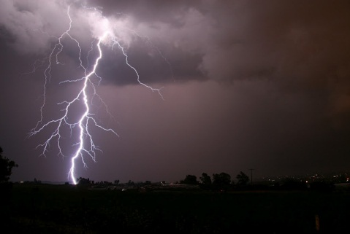 | A) Lightning never strikes the same place twice.  - Do you enjoy watching lightning storms?  - Does lightning and thunder frighten you?  - What do you like to do on a rainy day? | □ Fact  □ Fiction
 | B) Swearing reduces pain.  - Do you enjoy swearing?  - Do you swear if you are in pain?  - Do you know how to swear in another language?  - Do you have a high or low tolerance for pain?  - Do you know any methods for reducing pain? | □ Fact  □ Fiction
 | C) A dog's mouth is cleaner than a human's.  - Do you like dogs? Why or why not?  - Would you let a dog lick your face?  - Would you lick dog’s face?  - What kind of toothpaste do you usually use?  - What color is your toothbrush? | □ Fact  □ Fiction

Fold here

A) In fact lightning favors certain spots, particularly high locations. The Empire State Building is struck about 25 times every year. Ben Franklin grasped the concept long ago and mounted a metal rod atop the roof of his home, then ran a wire to the ground, thereby inventing the lightning rod.

B) Researchers have found that swearing can have a painkilling power, especially for people that don’t regularly curse. Students were asked to dip their arms into a bucket of icy water, while repeatedly uttering a swear word. The results showed that volunteers were able to keep their arms in the icy water longer when they were swearing than they could when they were uttering a harmless word. For the volunteers who weren’t habitual swearers, swearing was four times more likely to ease the pain caused by the icy water.

C) Despite a habit of licking things no human would dare, Fido's mouth is often touted as scientifically more sterile. Truth is, oral bacteria are so species-specific that one can't be considered cleaner than the other, just different.
6
Photo 1 by أسامة الطيب, Photo 2 by Crosa, Photo 3 by João Paulo Corrêa de Carvalho. All Photos CC BY.

 | A) If you fire a bullet into a car’s gas tank, it will explode.  - Have you ever shot a gun?  - Do you like action movies that show many explosions?  - Do you enjoy driving?  - Have you ever seen an explosion in real life? | □ Fact  □ Fiction
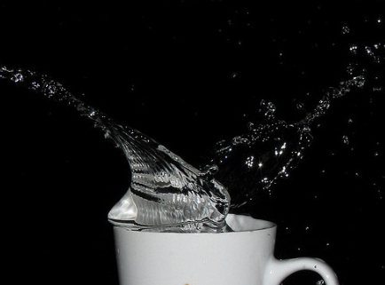 | B) Boiling a cup of water in the microwave can cause it to explode.  - Do you usually boil water in the microwave?  - How often do you use your microwave?  - Do you prefer tea of coffee?  - What’s your favorite kind of tea or coffee and how often do you drink it? | □ Fact  □ Fiction
 | C) Coca-Cola originally contained cocaine.  - Do you prefer Coke or Pepsi?  - Do you like any other soft drinks besides cola?  - What is your favorite beverage besides water?  - Do you think soft drinks should be banned from school cafeterias? | □ Fact  □ Fiction

Fold here

A) Bullets do not spark, so while a bullet can make an unsightly hole in the side of the car, and an annoying leak in the fuel tank, it will not cause the vehicle to instantly explode.

B) Although it requires a very specific set of circumstances for this phenomenon to occur, it has happened enough times that the U.S. Food & Drug Administration has issued a warning. When pure water is microwaved in a perfectly clean ceramic or glass cup for too long, it can prevent bubbles from forming and the water becomes super-heated. When the water is disturbed (such as by picking up the cup or adding something to it), it will boil violently and even "erupt" out of the cup.

C) Cocaine used to be a common ingredient in medicines, and Coca-Cola was developed as a medicinal elixir. In fact, Coca-Cola got its name from a blend of coca leaf and kola nut extracts used in the original 1885 formula. When cocaine was later discovered to be harmful and addictive, the company phased it out, leaving only trace amounts to justify the name. By 1929, the beverage was completely cocaine-free.

7
Photo 1 by unknown, Photo 2 by Harish Rao / CC BY, Photo 3 by lizzie_2985 / CC BY.

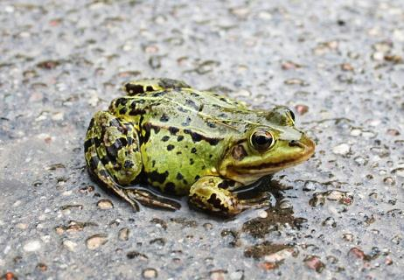 | A) Frogs can rain from the sky.  - What are some good activities for a rainy day?  - Have you ever experienced an extreme weather phenomenon (such as a typhoon, flood, blizzard, etc.)?  - What would you do if frogs starting raining down?  - Do you like frogs? Why or why not? | □ Fact  □ Fiction
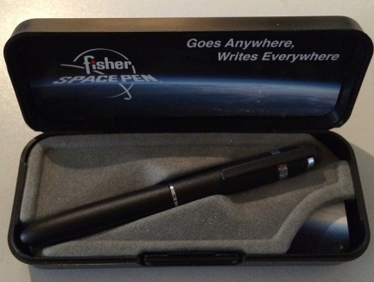 | B) NASA spent millions of dollars to develop a pen that would write in space, while the Soviet cosmonauts simply used pencils.  - Do you own any expensive or unique pens?  - Do you prefer using mechanical or regular pencils?  - Would being an astronaut be a good job? Why or why not? | □ Fact  □ Fiction
 | C) You can catch a cold if you go outside in the winter with wet hair.  - Have you ever gone outside with wet hair?  - How do you usually dry your hair: air dry, towel, or hair dryer?  - How often do you catch a cold?  - What do you do to prevent catching a cold? | □ Fact  □ Fiction

Fold here

A) For millennia, people have reported a rare and strange phenomenon: a sudden rain of frogs — or fish or worms — from the sky. While it's not the most common weather phenomenon in the world, it's not as rare as you might think. Reports of raining frogs or other unexpected objects happen at least once a decade or so. The mostly likely explanation is that strong winds, such as those in a tornado or hurricane suck up a school of fish or frogs and “rain” them elsewhere. Maybe the expression “it’s raining cats and dogs” should be changed to “it’s raining fish and frogs”.

B) At first both the USSR space program and NASA used pencils for their missions. However, pencils are highly flammable and the broken tips that drifted around were a potential hazard. So, in 1965 the Fisher Pen Company developed a space pen that could write upside-down, in frigid or roasting conditions, with an investment of 1 million dollars. None of the money came from NASA. Fisher offered the AG-7 "Anti-Gravity" Space Pen to NASA and they began using it on spaceflights in 1967. Since then and until this day, both Russian and American space crew have been using the Fisher company antigravity pen, and it's even offered for sale to the general public.

C) In one survey, 40 percent of mothers said they believed sending their kids out in the cold weather with a wet head would get them sick. However, this idea is, like so many other old warnings, just an old wives' tale.
8

A) Source: http://science.howstuffworks.com/nature/climate-weather/storms/rain-frog.htm Photo: Christine und Hagen Graf / CC BY
B) Source: http://skeptics.stackexchange.com/questions/12518/did-nasa-invest-a-million-dollars-in-the-research-of-a-space-pen-when-the-ussr Photo: Myrddin the Wicca Man / CC BY
C) Source: http://health.howstuffworks.com/diseases-conditions/cold-flu/wet-head-cold.htm Photo: Stewart Black / CC BY

