

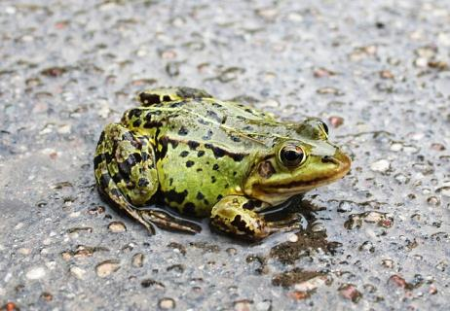 | A) Frogs can rain from the sky.  - What are some good activities for a rainy day?  - Have you ever experienced an extreme weather phenomenon (such as a typhoon, flood, blizzard, etc.)?  - What would you do if frogs starting raining down?  - Do you like frogs? Why or why not? | □ Fact  □ Fiction
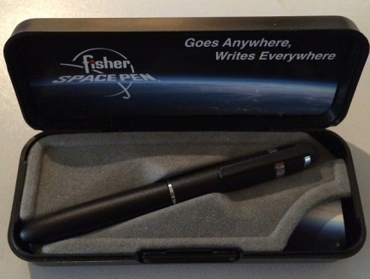 | B) NASA spent millions of dollars to develop a pen that would write in space, while the Soviet cosmonauts simply used pencils.  - Do you own any expensive or unique pens?  - Do you prefer using mechanical or regular pencils?  - Would being an astronaut be a good job? Why or why not? | □ Fact  □ Fiction
 | C) You can catch a cold if you go outside in the winter with wet hair.  - Have you ever gone outside with wet hair?  - How do you usually dry your hair: air dry, towel, or hair dryer?  - How often do you catch a cold?  - What do you do to prevent catching a cold? | □ Fact  □ Fiction

Fold here

A) For millennia, people have reported a rare and strange phenomenon: a sudden rain of frogs — or fish or worms — from the sky. While it's not the most common weather phenomenon in the world, it's not as rare as you might think. Reports of raining frogs or other unexpected objects happen at least once a decade or so. The mostly likely explanation is that strong winds, such as those in a tornado or hurricane suck up a school of fish or frogs and “rain” them elsewhere. Maybe the expression “it’s raining cats and dogs” should be changed to “it’s raining fish and frogs”.

B) At first both the USSR space program and NASA used pencils for their missions. However, pencils are highly flammable and the broken tips that drifted around were a potential hazard. So, in 1965 the Fisher Pen Company developed a space pen that could write upside-down, in frigid or roasting conditions, with an investment of 1 million dollars. None of the money came from NASA. Fisher offered the AG-7 "Anti-Gravity" Space Pen to NASA and they began using it on spaceflights in 1967. Since then and until this day, both Russian and American space crew have been using the Fisher company antigravity pen, and it's even offered for sale to the general public.

C) In one survey, 40 percent of mothers said they believed sending their kids out in the cold weather with a wet head would get them sick. However, this idea is, like so many other old warnings, just an old wives' tale.
8

A) Source: http://science.howstuffworks.com/nature/climate-weather/storms/rain-frog.htm Photo: Christine und Hagen Graf / CC BY
B) Source: http://skeptics.stackexchange.com/questions/12518/did-nasa-invest-a-million-dollars-in-the-research-of-a-space-pen-when-the-ussr Photo: Myrddin the Wicca Man / CC BY
C) Source: http://health.howstuffworks.com/diseases-conditions/cold-flu/wet-head-cold.htm Photo: Stewart Black / CC BY

