

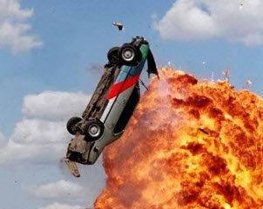 | A) If you fire a bullet into a car’s gas tank, it will explode.  - Have you ever shot a gun?  - Do you like action movies that show many explosions?  - Do you enjoy driving?  - Have you ever seen an explosion in real life? | □ Fact  □ Fiction
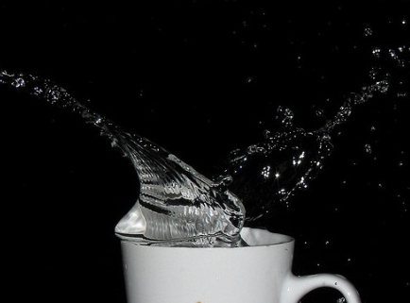 | B) Boiling a cup of water in the microwave can cause it to explode.  - Do you usually boil water in the microwave?  - How often do you use your microwave?  - Do you prefer tea of coffee?  - What’s your favorite kind of tea or coffee and how often do you drink it? | □ Fact  □ Fiction
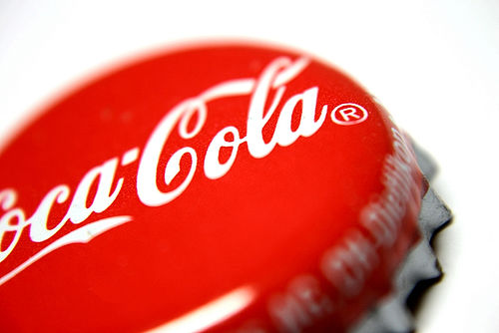 | C) Coca-Cola originally contained cocaine.  - Do you prefer Coke or Pepsi?  - Do you like any other soft drinks besides cola?  - What is your favorite beverage besides water?  - Do you think soft drinks should be banned from school cafeterias? | □ Fact  □ Fiction

Fold here

A) Bullets do not spark, so while a bullet can make an unsightly hole in the side of the car, and an annoying leak in the fuel tank, it will not cause the vehicle to instantly explode.

B) Although it requires a very specific set of circumstances for this phenomenon to occur, it has happened enough times that the U.S. Food & Drug Administration has issued a warning. When pure water is microwaved in a perfectly clean ceramic or glass cup for too long, it can prevent bubbles from forming and the water becomes super-heated. When the water is disturbed (such as by picking up the cup or adding something to it), it will boil violently and even "erupt" out of the cup.

C) Cocaine used to be a common ingredient in medicines, and Coca-Cola was developed as a medicinal elixir. In fact, Coca-Cola got its name from a blend of coca leaf and kola nut extracts used in the original 1885 formula. When cocaine was later discovered to be harmful and addictive, the company phased it out, leaving only trace amounts to justify the name. By 1929, the beverage was completely cocaine-free.

7
Photo 1 by unknown, Photo 2 by Harish Rao / CC BY, Photo 3 by lizzie_2985 / CC BY.

