

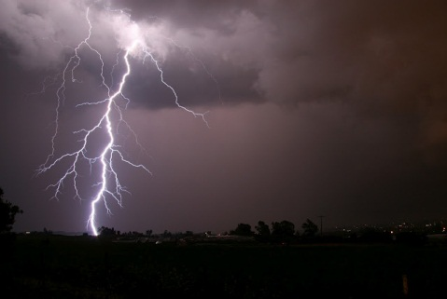 | A) Lightning never strikes the same place twice.  - Do you enjoy watching lightning storms?  - Does lightning and thunder frighten you?  - What do you like to do on a rainy day? | □ Fact  □ Fiction
 | B) Swearing reduces pain.  - Do you enjoy swearing?  - Do you swear if you are in pain?  - Do you know how to swear in another language?  - Do you have a high or low tolerance for pain?  - Do you know any methods for reducing pain? | □ Fact  □ Fiction
 | C) A dog's mouth is cleaner than a human's.  - Do you like dogs? Why or why not?  - Would you let a dog lick your face?  - Would you lick dog’s face?  - What kind of toothpaste do you usually use?  - What color is your toothbrush? | □ Fact  □ Fiction

Fold here

A) In fact lightning favors certain spots, particularly high locations. The Empire State Building is struck about 25 times every year. Ben Franklin grasped the concept long ago and mounted a metal rod atop the roof of his home, then ran a wire to the ground, thereby inventing the lightning rod.

B) Researchers have found that swearing can have a painkilling power, especially for people that don’t regularly curse. Students were asked to dip their arms into a bucket of icy water, while repeatedly uttering a swear word. The results showed that volunteers were able to keep their arms in the icy water longer when they were swearing than they could when they were uttering a harmless word. For the volunteers who weren’t habitual swearers, swearing was four times more likely to ease the pain caused by the icy water.

C) Despite a habit of licking things no human would dare, Fido's mouth is often touted as scientifically more sterile. Truth is, oral bacteria are so species-specific that one can't be considered cleaner than the other, just different.
6
Photo 1 by أسامة الطيب, Photo 2 by Crosa, Photo 3 by João Paulo Corrêa de Carvalho. All Photos CC BY.

