

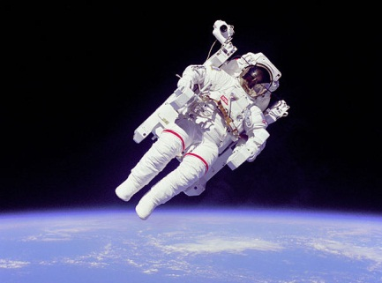 | A) There is no gravity in space.  - Would you like to be a space tourist?  - Should the government spend money on space exploration?  - Are you interested in astronomy?  - Are you interested in astrology?  - Do you believe we will ever make contact with aliens? | □ Fact  □ Fiction
 | B) Yawning is "contagious".  - Do you enjoy yawning?  - Do you feel like yawing now?  - What time do you usually go to sleep?  - Do you yawn more at night or in the morning? | □ Fact  □ Fiction
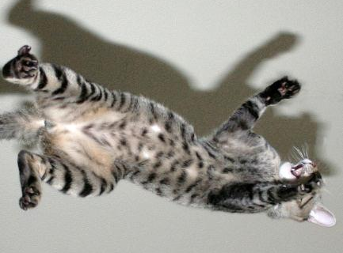 | C) A falling cat will always land on its feet.  - Do you like cats? Why or why not?  - Have you ever fallen? What happened?  - Are you generally clumsy or coordinated? | □ Fact  □ Fiction

Fold here

A) Blame the term "zero-gravity" for this common misconception. Gravity is everywhere, even in space. Astronauts look weightless because they are in continuous freefall towards the Earth, staying aloft because of their horizontal motion. The effect of gravity diminishes with distance, but it never truly goes away. Oh, and while we're at it, it's also untrue that space is a vacuum. There are all kinds of atoms out there, albeit sometimes far apart (and this thin gas adds to the collective gravity budget, too!)

B) Empirically, this is tough to deny; perhaps you'll yawn while reading this. The real question is whether there's actually something physiological at work here, and the answer is likely yes: even chimpanzees mimic each other's yawns.

C) Studies have demonstrated that, when dropped from most heights, cats will land gracefully on their feet. Results change only with cats dropped upside-down from a height of one foot or less. We're not suggesting you try this at home.

5
Photo 1 NASA / Public Domain, Photo 2 by riesma pawestri, Photo 3 (edit) by DAN SCOTT / CC BY

