

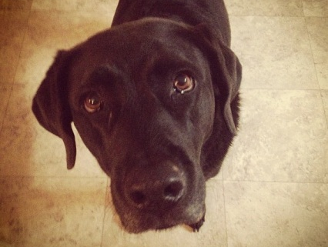 | A) Animals can predict natural disasters.  - Do you have any pets?  - What’s your favorite animal? Why?  - Are you good at predicting the future?  - Do you believe in fortune-telling?  - Have you ever experienced a natural disaster? | □ Fact  □ Fiction
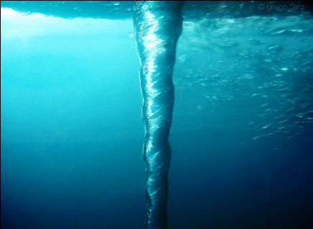 | B) Water drains backwards in the Southern Hemisphere due to the Earth's rotation.  - Do you know which direction water drains in your home?  - Have you ever been to the Southern Hemisphere?  - Would you rather visit the North or South pole? Why? | □ Fact  □ Fiction
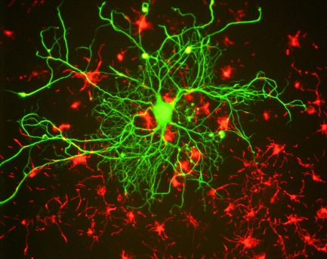 | C) Adults don't grow new brain cells.  - Do you do any brain exercises?  - Do you have a good memory?  - Do you enjoy trivia games?  - Are you learning anything new these days? | □ Fact  □ Fiction

Fold here

A) There is no evidence that animals possess a mysterious sixth-sense allowing them to predict natural disasters. Their keen senses of smell, hearing, and sharp instincts alone are enough to send them scattering for the hillsides during a hurricane or tsunami. And even so, animals often die during natural disasters, so if they do have some sort of sixth sense, it's not worth much.

B) In principle, the Coriolis effect would cause water to drain clockwise in the Northern hemisphere and counterclockwise in the Southern hemisphere. However, in reality, the small irregularities in your sink and tub have a much bigger effect than the Earth’s rotation. Tests that you can easily perform in a few washrooms will show that water spins in both directions depending on the sink’s structure, not the hemisphere.

C) Much of a human's crucial brain development happens during childhood, but it isn't all downhill from there. Studies have shown that neurons continue to grow and change well into the adult years.

2
Photo 1 by germanny, Photo 2 by Ignacio Sanz, Photo 3 by Gerry Shaw. All photos CC BY.

