


  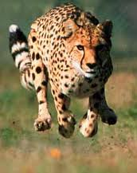 |   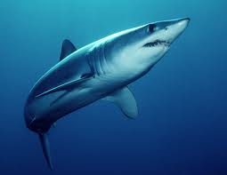 |   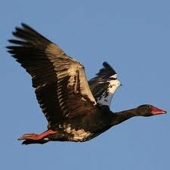
Cheetah | Mako Shark | Spur-winged Goose

Fastest: | Rank from fastest to slowest.
Lifespan: | Rank from longest to shortest lifespan.
Population: | Rank from highest to lowest population.
Opinion: | Rank from most to least favorite.

----------------------------------------------------------------------- F O L D ----------------------------------------------------------------------------

Fastest: C – 142 kph / A – 110 kph / B – 74 kph  The cheetah is the world’s fastest land animal reaching speeds of up to 110 km/h in short bursts, but it is not the world’s fastest animal. In fact, even the spur-winged goose (the world’s largest goose) can fly faster - up to 142km/h. The shortfin mako is is the world’s fastest shark, but it is the slowest of the three. The mako has been recorded at 50 km/h with bursts of up to 74 km/h. | - Are you a fast runner?  - Would you rather be a sprinter or a marathoner?  - Have you or would you like to run a marathon?  - Do you ever feel the need for speed?  - What’s the fastest you’ve ever driven?
Lifespan: B – 32 / A - 17 / C - 11  In 2006, a landmark study showed that the maximum age for male mako sharks was 29 years, and 32 years for females. A cheetah can live up to 14 years in the wild or 17 in captivity. The spur-winged goose has a maximum lifespan of about 11 years in captivity. | - Eighty years is the average lifespan for humans. Do you think it’s long enough?  - Are you doing anything to live longer?  - Would you ever consider cryogenics?  - Someday modern medicine will enable humans to live forever. Do you agree?
Population: C / B / A  The cheetah is an endangered species. Its population numbers have declined from more than 100,000 in 1900 to approximately 9,000-12,000 today. The decreasing numbers are mainly due to loss of habitat and conflicts with people. The shortfin and longfin mako sharks have been listed as "vulnerable" fish due to less frequent sightings as well as the practice of harvesting mako shark meat and fins, but conservationists do not have a solid estimate of their population numbers. The population size of the spur-winged goose is very large with an estimate of around 350,000 - 500,000. | - Do you think the world is overpopulated? What can we do about it?  - Is it a good idea that many people are only having one child these days?  - Would you rather live in a crowded city or in the country with no one else around?  - Would you rather be a cheetah, a shark, or a goose?  - If you could be any animal which would you like to be?
Opinion: | - Explain your opinion.  - What’s your favorite animal?

