


  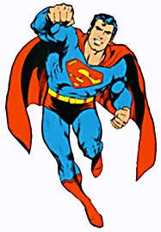 |   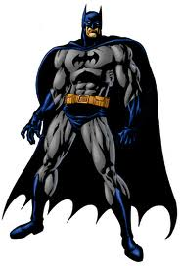 |   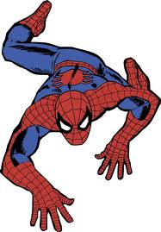
Superman | Batman | Spiderman

Year created: | Rank from earliest to latest.
Strength: | Rank from strongest to weakest.
Height: | Rank from tallest to shortest.
Opinion: | Rank from most to least favorite.

----------------------------------------------------------------------- F O L D ----------------------------------------------------------------------------

Year created: A – 1938 / B – 1939 / C – 1962  Superman was created by writer Jerry Siegel and artist Joe Shuster and first appeared in Action Comics #1 in June, 1938. Batman was created by the artist Bob Kane and writer Bill Finger and appeared in Detective Comics #27 in May, 1939. Spider-man was created by writer-editor Stan Lee and writer-artist Steve Ditko. He first appeared in Amazing Fantasy #15 in August, 1962. | - Do you like comic books?  - What’s your all time favorite comic?  - What’s the most famous comic in your country?  - How many comic books do you own?
Strength: A / C / B  In 1976, DC Comics and Marvel published a comic book entitled Superman vs. the Amazing Spider-Man: The Battle of the Century. In it Superman mistakenly blamed Spider-man for kidnapping Lois Lane and a fight ensued. At the end of the fight, Spider-man surrenders after bouncing off Superman’s invulnerable body.  Batman does not have any superpowers, although he has elevated himself to near superhuman status through years of rigorous training. | - Would you rather write, pencil, or color comics (professionally)?  - Who is your favorite villain of all time? Why?  - Do you prefer American or Japanese comics? Explain.  - Do you ever read comics online?  - Who is stronger: Superman or Pikachu?
Height: A – 6’3” / B – 6’2” / C – 5’10”  Here are the physical attributes of each superhero according to the official DC and Marvel websites:  Superman is 6’3”, 225 lbs with blue eyes and black hair.  Batman is 6’2”, 210 lbs with blue eyes and black hair.  Spider-man is 5’10”, 167 lbs with hazel eyes and brown hair. | - Among the 3 superheroes, whose physical attributes are most appealing to you?  - Which of your friends in real life is most like a superhero?  - If you could have any superpower which would you choose?  - What would you do with that power?  - What would you name yourself if you became a superhero?
Opinion: | - Explain your opinion.  - Would you rather be Superman, Batman, or Spiderman? Why?  - Who would you rather have as a friend?

