


  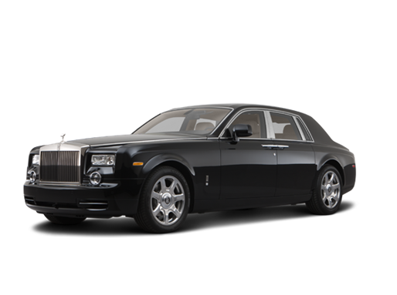 |   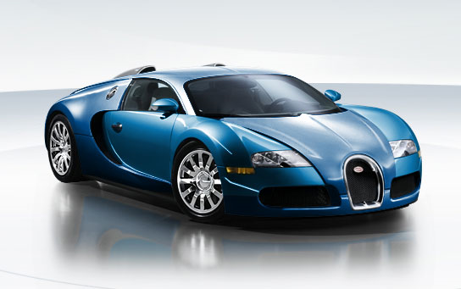 |   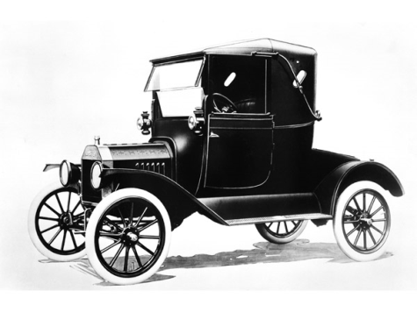
Rolls Royce Phantom | Bugatti Veyron | Ford Model T

Price: | Rank from most to least expensive.
Top Speed: | Rank from fastest to slowest.
Fuel Efficiency: | Rank from most to least efficient.
Opinion: | Rank from best to worst.

----------------------------------------------------------------------- F O L D ----------------------------------------------------------------------------

Price: B - $2,300,000 / A - $380,000-450,000 / C - $6,500-$34,000  What is the most expensive car in the world? The 1931 Bugatti Royale Kellner Coupe was sold for $8,700,000 in 1987. However, if you want to buy something on the market today, the Bugatti Veyron will set you back a cool $2.3 million. This is by far the most expensive street legal car available on the market today. | - Do you like expensive cars?  - Do you prefer sports cars, luxury sedans, SUVs, or some other type of car?  - Do men / women with expensive cars look more attractive?
Top Speed: B - 267.86 mph / A - 149 mph / C - 45 mph  The ludicrously fast 1001-horsepower Bugatti Veyron set a Guinness-certified speed record for a production car, with a two-way average speed of 267.86 miles per hour (431.07 km/h). The production cars are "limited" to 257.91 mph to protect the tires from disintegrating. The Model T produced from 1909-1927 had a top speed of 45 mph (72.4 km/h) under ideal conditions on a flat smooth road. | - Do you like to drive fast?  - What’s the fastest you’ve ever driven?  - Do you think most speed limits are too low, just right, or too high?  - Would you like to have a self-driving car?  - Do you think we will ever have flying cars? Would you like to have one?
Fuel Efficiency: C - 25 mpg / A - 14 mpg / B - 5-10 mpg  Ford's Model T, which went 25 miles on a gallon of gasoline, was more fuel efficient than most modern cars, such as the Ford Explorer SUV, which manages just 16 miles per gallon. Fuel consumption for the Bugatti Veyron is in the range of 5 to 10 mpg, but at full throttle it only gets 2.1mpg, which means it would empty its 100 liter (26.4 gallon) fuel tank in about 12.5 minutes – which is good, because at top speed the tires would only last for about 15 minutes. | - Do you care about fuel efficiency?  - Do you think fuel prices are too high?  - Which type of fuel is the best: gasoline, diesel, LPG, or something else?  - What do you think about hybrid or electric cars?
Opinion: | - Explain your opinion.  - What’s your favorite car?  - Do you enjoy driving? Why or why not?

