


  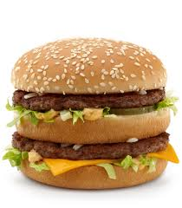 |   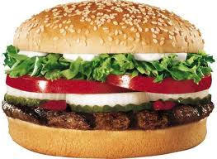 |   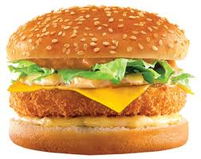
McDonalds Big Mac | Burger King Whopper | Lotteria Shrimp Burger

Size: | Rank from biggest to smallest.
Calories per 100 grams: | Rank from most to least calories per 100 g.
Year created: | Rank from earliest to latest.
Opinion: | Rank from most to least favorite.

----------------------------------------------------------------------- F O L D ----------------------------------------------------------------------------

Size: B – 290g/ A – 214g / C – 158g  Burger King’s answer to the Big Mac is The Whopper and it is definitely the winner in the size category at 290 grams. | - Do you like fast food?  - What’s your favorite fast food restaurant?  - How often do you eat fast food?  - Do you prefer to eat many small meals, or a few big meals?
Calories: C – 268 kcal / A – 252 kcal / B – 231 kcal  The Whopper (670 kcal) has more calories than McDonald's Big Mac (540 kcal) and Lotteria’s Shrimp Burger (421 kcal) but it is the largest. Therefore, the Whopper actually contains the fewest calories per gram. The Whopper contains 231 kcal per 100 g and the Big Mac contains 252 kcal per 100 g. The Shrimp Burger is the smallest, but actually contains the most calories – 268 kcal per 100 g. | - Do you ever count calories?  - Have you ever been on a diet?  - Are you satisfied with your weight right now?  - Have you consumed many calories today?  - What exercises to do usually do to burn calories?
Year created: B - 1957 / A - 1967 / C - 1977  The Whopper was created in 1957 and sold for 37 cents. The Big Mac first debuted in 1967 at a selling price of 45 cents. The Shrimp Burger was first made in 1977 and is one of the most popular burgers at Lotteria. | - Did you know that the Whopper is older than the Big Mac?  - Which restaurant makes the tastiest hamburgers—Lotteria, Burger King or McDonalds or another restaurant?  - Do you often eat leftovers?  - Besides food from your own country, which country’s food is your favorite?
Opinion: | - Explain your opinion.  - Which burger is the most unique: Big Mac because it has a center bun, Whopper because it is flame-broiled, or Shrimp Burger because it is made with shrimp?

