
POLL 1: What kind of games do you prefer? |  |  |  | 
□ | Video games
□ | Board games
□ | Card games
- When is the last time you played a video, board, or card game?
- Do you have a favorite video / board / card game?
- Many parents dislike video games but think board and card games are OK. Do you agree?
- Do you think violent video games are harmful to children?
POLL 2: Besides Earth, which is your favorite planet?
□ |  | Mercury | 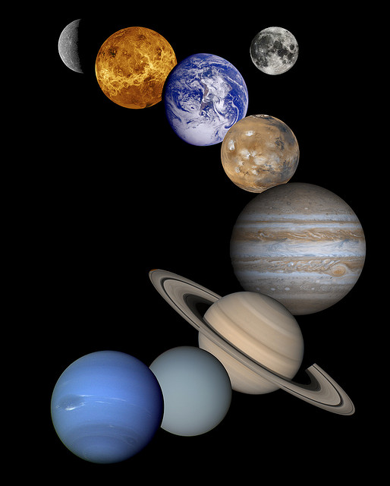
□ |  | Venus
□ |  | Mars
□ |  | Jupiter
□ |  | Saturn
□ |  | Uranus
□ |  | Neptune
- What is the reason for your choice?
- Would you like to be an astronaut or space tourist?
- Would you like to meet an alien? Why or why not?
- Do you believe that humans are the smartest creatures in the universe?
- Do you think the universe is infinite or finite?
POLL 3: Do you like ice cream?
□ |  | Yes | 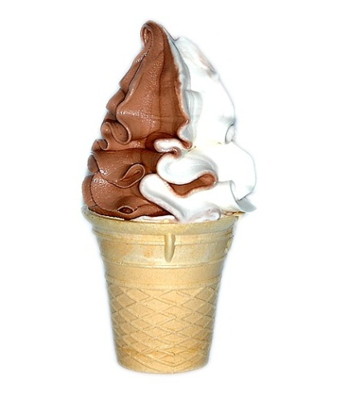
□ |  | No
- What’s your favorite flavor?
- How often do you eat ice cream?
- Do you prefer hard or soft ice cream?
- Do you prefer ice cream in a cone, in a cup, or on a stick?
- Do you have a favorite ice cream shop?
- Do you have any ice cream in your freezer right now?

No. 12

What kind of games do you prefer?
Video games | 44.6% | 461 votes
Board games | 29.1% | 301 votes
Card games | 26.3% | 272 votes
http://shirt.woot.com/forums/viewpost.aspx?postid=5240674&pageindex=1&replycount=11#post5241601

Besides Earth, which is your favorite planet?
Mercury | 4% | 5 votes
Venus | 9.6% | 12 votes
Mars | 15.2% | 19 votes
Jupiter | 23.2% | 29 votes
Saturn | 20.8% | 26 votes
Uranus | 10.4% | 13votes
Neptune | 16.8% | 21 votes
http://www.socialanxietysupport.com/forum/f36/what-is-your-favorite-planet-besides-earth-208683/

Do you like ice cream?
Yes | 100% | 1 vote
No | 0% | 0 votes
Survey conducted on myself.

No. 12

