
POLL 1: Where do you eat dinner?
□ | At dinner table |  |  |  | 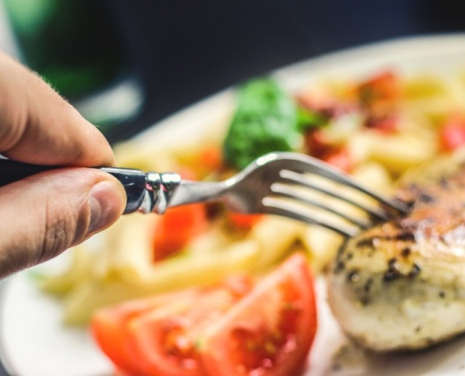
□ | In front of TV
□ | Both / Other
- Do you always eat dinner at the same time?
- Who usually cooks in your family?
- How often do you go out for dinner?
- Which is your favorite meal of the day, breakfast, lunch, or dinner?
- Do you agree with the adage: Eat breakfast like a king, lunch like a prince, and dinner like a pauper?
POLL 2: If you ran away and joined the circus, which circus job which you most like to do?
□ |  | Snake charmer | □ | Ticket seller | 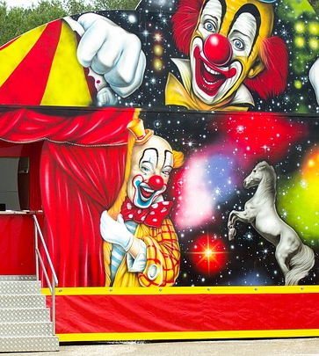
□ |  | Flying trapeze artist | □ | Popcorn vender
□ |  | Bareback rider | □ | Tightrope walker
□ |  | Lion tamer | □ | Clown
□ |  | Booth operator | □ | Fortune teller
□ |  | Human cannonball | □ | Strong man
□ |  | Ringmaster | □ | Bearded lady
- Have you ever been to the circus?
- Have you ever seen Cirque Du Soleil?
- Do you like clowns? Do you find them funny or scary?
- Can you remember the last time you saw a live show? What was it?
- Would you rather see a circus, play, concert, or movie?
POLL 3: On the beach do you prefer sandals or bare feet?
□ |  | Sandals |  |  | 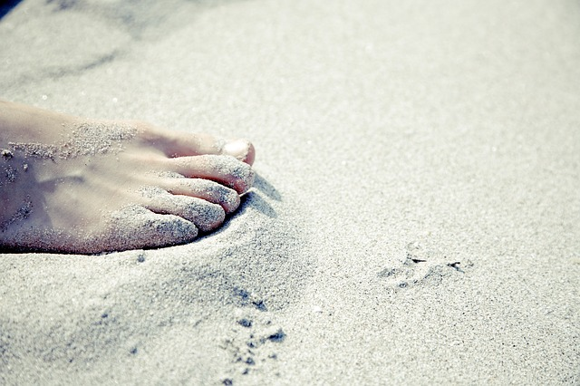
□ |  | Bare feet
- Do you enjoy having a vacation at the beach?
- When is the last time you’ve been to the beach?
- Where is the most beautiful beach you’ve ever seen?
- Do you often wear sandals?
- Are you wearing comfortable shoes today?
- Do you like high heels?
- Some people, called ‘barefooters’, never wear shoes because they think it’s unnatural and unhealthy. Do you agree?

No. 11

Where do you eat dinner?
At dinner table | 22% | 22 votes
In front of TV | 53% | 53 votes
Both / Other | 25% | 25 votes
http://community.i-do.com.au/index.php?showtopic=86219&pid=1418507&mode=threaded&show=&st=&

If you ran away and joined the circus, which circus job which you most like to do?
Snake charmer | 2.91% | 278 votes
Flying trapeze artist | 14.55% | 1,391 votes
Bareback rider | 5.77% | 551 votes
Lion tamer | 6.92% | 661 votes
Booth operator | 5.31% | 507 votes
Human cannonball | 4.65% | 444 votes
Ringmaster | 6.42% | 614 votes
Ticket seller | 7.8% | 745 votes
Popcorn vender | 11.31% | 1,081 votes
Tightrope walker | 3.47% | 332 votes
Clown | 6.56% | 627 votes
Fortune teller | 16.33% | 1,561 votes
Strong man | 5.42% | 518 votes
Bearded lady | 2.58% | 247 votes
http://www.funjoint.com/polls.htm

On the beach do you prefer sandals or bare feet?
Sandals | 16.9% | 100 votes
Bare feet | 83.1% | 490 votes
http://www.quizopolis.com/poll.php?pollid=5490&viewresults=1

No. 11

