
POLL 1  Which is your favorite monster? |  |  |  |  | 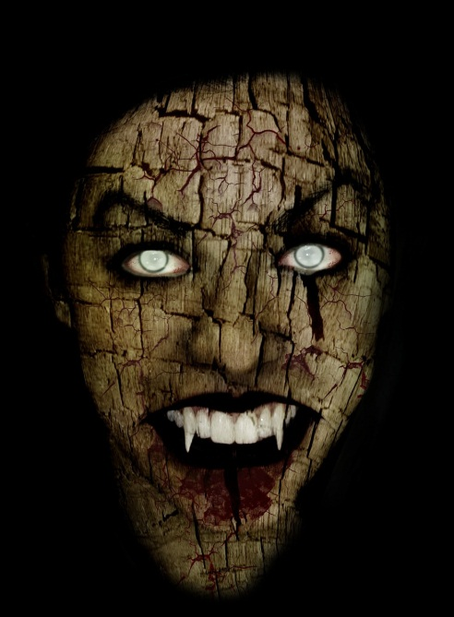
□ | Vampires
□ | Zombies
□ | Werewolves
- Do you like horror movies or books? When is the last time you saw or read one?
- Is it possible that vampires, zombies, or werewolves could be real?
- Would you rather be a vampire, zombie, or werewolf? Why?
- What would happen if a zombie bit a vampire or vice versa?
- What would happen if you were bitten by a vampire, zombie and werewolf at the same time?
- Have you seen more movies about vampires, zombies or werewolves?
- Have you ever read a Stephen King book?
POLL 2
Which of these fantasy creatures do you most wish were real?
□ |  | Fairies | □ | Elves | 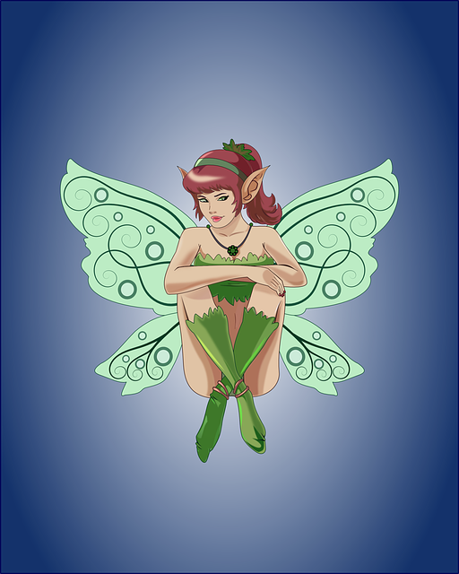
□ |  | Unicorns | □ | Dragons
□ |  | Mermaids | □ | Wizards
□ |  | Genies | □ | Vampires
□ |  | Leprechauns | □ | Oompa Loompas
- What would you do with the creature if it were real?
- If these creatures were real would the world be better or worse off?
- Which creature would you rather be?
- If a genie granted you 3 wishes, what would you wish for?
- What’s your favorite fairy tale?
- Do you like fantasy books or movies? When is the last time you read or saw one?
POLL 3
Do you believe in ghosts?
□ |  | Yes |  |  |  | 
□ |  | No
- Have you ever seen a ghost?
- Would you like to see a ghost? Why or why not?
- Would you like to be a ghost? Why or why not?
- Do you like ghost stories?

No. 10

Which is your favorite monster?
Vampires | 45% | 26 votes
Zombies | 31% | 18 votes
Werewolves | 24% | 14 votes
http://www.stephenking.com/forums/showthread.php/21477-Vampires-Zombies-or-Werewolves

Which of the following talents would you most like to have?
Fairies | 13.82% | 1,269 votes
Unicorns | 9.77% | 897 votes
Mermaids | 10.13% | 930 votes
Genies | 19.85% | 1,822 votes
Leprechauns | 3.92% | 360 votes
Elves | 4.18% | 384 votes
Dragons | 8.44% | 775 votes
Wizards | 14.54% | 1,335 votes
Vampires | 9.14% | 839 votes
Oompa Loompas | 6.2% | 569 votes
http://www.funjoint.com/polls.htm

Do you believe in ghosts?
Yes | 71.5% | 1127 votes
No | 28.5% | 449 votes
http://www.quizopolis.com/

No. 10

