
POLL 1  Do you keep a diary? |  |  |   Joel Montes de Oca
□ | Yes.
□ | No.
□ | I used to.
- Do you think writing in a diary is good for mental health?
- Do you enjoy writing? Have you ever written a story or poem?
- If you have a diary, how often do you read it?
- If you have a diary, would you ever let someone read it?
- If you found someone’s diary, would you read it? Whose diary would you most want to read?
POLL 2
Which of the following talents would you most like to have?
□ |  | To have a golden voice. (sing well) |   Bill Brookman / worldwideperformers.com
□ |  | To inspire awe with my amazing dance moves. (dance well)
□ |  | To dazzle others with the written word. (write well)
□ |  | To display brilliance on a musical instrument. (play music well)
□ |  | To dominate a sport with my athletic prowess. (play sports well)
- What did you want to be when you were a child?
- If you could start a new career today, what would you probably choose?
- Would you rather double your income (and keep your current schedule) or only work half of the year (and keep your current salary)?

POLL 3
Which kind of turtle do you like better?
□ |  | Land |  | 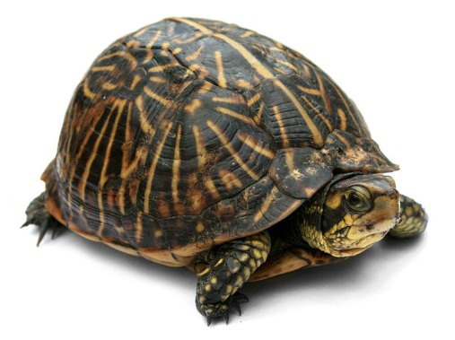  Jonathon Zander
□ |  | Water
- Have you ever touched a turtle?
- Would you like to have a pet turtle? Why or why not?
- Would you rather be a turtle or a rabbit? Why?
- Do you know the story of the tortoise and the hare (turtle and rabbit)? Do you agree with the moral of the story?

No. 9

Do you keep a diary?
Yes. | 22% | 57 votes
No. | 45% | 115 votes
I used to. | 33% | 86 votes
http://www.quizopolis.com/poll/5106/Do-you-keep-a-diary?/

Which of the following talents would you most like to have?
To have a golden voice. (sing well) | 27% | 404 votes
To inspire awe with my amazing dance moves. (dance well) | 14% | 203 votes
To dazzle others with the written word. (write well) | 26% | 376 votes
To display brilliance on a musical instrument. (play music well) | 18% | 264 votes
To dominate a sport with my athletic prowess. (play sports well) | 15% | 223 votes
http://www.queendom.com/polls/poll.htm?poll=58

Which kind of turtle do you like better?
Land | 84% | 32 votes
Water | 16% | 6 votes
http://www.quizopolis.com/poll/4575/Which-kind-of-Turtle-do-you-like-better?/

No. 9

