
POLL 1  Are you afraid of spiders? |  |  | 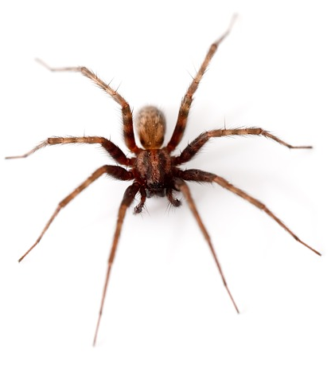
□ | Yes, I hate them.
□ | They’re creepy, but they don’t make me panic.
□ | No, I barely flinch when I see one.
- What do you do if you find a spider in your house?
- Do you usually squash bugs, use bug spray, or catch and release them?
- Are you more afraid of spiders, snakes or sharks?
- Are there any insects that you find fascinating or beautiful?
- Have you ever been bitten or stung by an animal or insect?
POLL 2
Which of the following jobs would you most like to have?
□ |  | Professional athlete |  | 
□ |  | Actor/actress
□ |  | President
□ |  | Rock star
□ |  | Unsure
- What did you want to be when you were a child?
- If you could start a new career today, what would you probably choose?
- Would you rather double your income (and keep your current schedule) or only work half of the year (and keep your current salary)?

POLL 3
Do you sing in the shower?
□ |  | Yes |  | 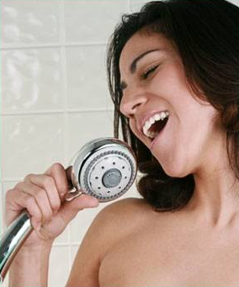
□ |  | No
- Are you a good singer?
- How often do you go to a singing room?
- Do you have a favorite song to sing?
- Do you prefer singing or dancing?
- Do you prefer showers or baths?

No. 8

Are you afraid of spiders?
Yes, I hate them. | 42% | 318 votes
They’re creepy, but they don’t make me panic. | 34% | 260 votes
No, I barely flinch when I see one. | 24% | 180 votes
http://www2.ljworld.com/polls/2011/mar/are-you-afraid-spiders/

Which of the following jobs would you most like to have?
Professional athlete | 29% | 291 votes
Actor/actress | 32% | 321 votes
President | 13% | 130 votes
Rock star | 13% | 130 votes
Unsure | 13% | 130 votes
http://maristpoll.marist.edu/823-acting-most-popular-%e2%80%9cdream-job%e2%80%9d-among-americans/

Do you sing in the shower?
Yes | 79% | 557 votes
No | 21% | 151 votes
http://www.quizopolis.com/poll/3572/Do-you-sing-in-the-shower?/

No. 8

