
POLL 1  How often do you read your horoscope? |  |  | 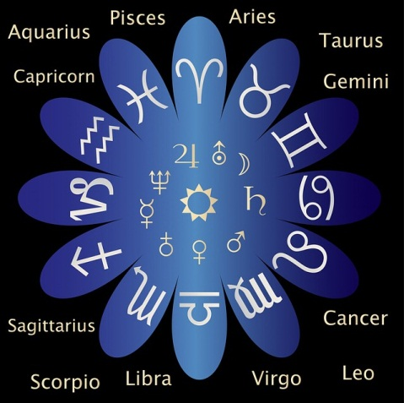
□ | Everyday
□ | Once a week
□ | Very rarely
□ | Never
- When is your birthday?
- What’s your sign? Do you prefer your eastern or western sign?
- Do you believe in destiny? Can our free-will alter destiny?
- Have you ever been to a fortune teller? Were the answers accurate?
- Does one’s day of birth affect personality? What about blood type?
POLL 2
What super power would you most like to have?
□ |  | Invisibility | 
□ |  | The ability to fly
□ |  | The ability to teleport
□ |  | The ability to read minds
□ |  | The ability to time travel
- Give reasons for your answer.
- Would you use your superpower for good or evil?
- Is there a super power not on the list that you’d like to have?
- Do you enjoy reading superhero comics or watching superhero movies?
- Do you have a favorite superhero?
- Do you think being a superhero would be a blessing or a burden?
POLL 3
How cluttered is your home?
□ |  | My home is a clutter-free zone, a haven for relaxation. | 
□ |  | I have a little clutter here and there, but nothing embarrassing.
□ |  | My house is moderately messy unless I have someone coming over, in which case I clean.
□ |  | Somebody needs to do an intervention; there’s so much mess I don't know where to begin cleaning.
- How often do you tidy up around the house?
- How do you get rid of old things? eg: throw it away, give it away, sell it
- Are you generally well organized?
- Are you a hoarder? Are you keeping some things that you should throw away?
- Do you have many paintings or photos hanging on the walls of your home?
- Is it possible to have beautiful clutter? ie: an artist’s studio or professor’s study?

No. 7

How often do you read your horoscope?
Everyday | 15% | 119 votes
Once a week | 10% | 79 votes
Very rarely | 39% | 309 votes
Never | 36% | 285 votes
http://www.cbsnews.com/stories/2011/10/02/60minutes/main20111831_page4.shtml

What super power would you most like to have?
Invisibility | 10% | 102 votes
The ability to fly | 16% | 163 votes
The ability to teleport | 11% | 103 votes
The ability to read minds | 28% | 255 votes
The ability to time travel | 28% | 255 votes
http://maristpoll.marist.edu/28-holy-super-powers-batman-mind-reading-and-time-travel-top-list/

How cluttered is your home?
My home is a clutter-free zone, a haven for relaxation. | 6% | 688 votes
I have a little clutter here and there, but nothing embarrassing. | 19% | 2206 votes
My house is moderately messy unless I have someone coming over, in which case I clean. | 37% | 4111 votes
Somebody needs to do an intervention; there’s so much mess I don't know where to begin cleaning. | 36% | 4059 votes
http://stress.about.com/gi/pages/poll.htm?poll_id=2832655558&linkback=http://stress.about.com/b/2011/04/06/ready-for-some-spring-cleaning.htm

No. 7

