
POLL 1  In the next century, do you think we will be able to create robots that look and act like human beings? |  |  | 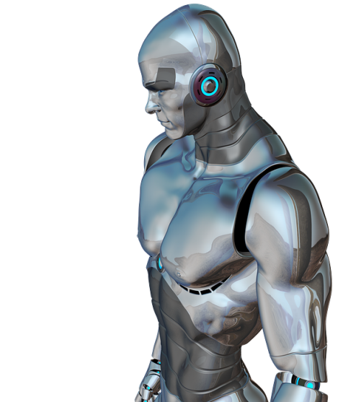
□ | Yes.
□ | No.
- Would you like to own a robot?
- Why do we want robots that look and act like humans?
- Do you think we can create robots that have free will?
- Do you think robots could turn against us (like in Terminator)?
POLL 2
What’s the best invention of all time?
□ |  | The wheel. | 
□ |  | The printing press.
□ |  | The lightbulb.
□ |  | The internet.
- Give reasons for your answer.
- Can you think of any other important inventions?
- Which of these inventions do you probably use the most?

POLL 3
Are people any smarter these days?
□ |  | Yes, humans are smarter and wiser than generations past. |  | 
□ |  | Sadly, we're worse off. People just seem to get dumber every generation.
□ |  | Status quo rules.
- Does technology, such as the internet, make us lazy and dumb or smart and efficient?
- Do smart people have fewer babies than dumb people?
- Would you rather be smart and sad, or dumb and happy?
- Which statement do you agree with more: “ignorance or bliss” or “knowledge is power”?


No. 6

In the next century, do you think we will be able to create robots that look and act like human beings?
Yes. | 70% | 718 votes
No. | 26% | 267 votes
Methodology: Conducted by CBS News, December 17 - December 19, 1999 and based on 1,026 telephone interviews. Sample: National adult.

What’s the best invention of all time?
The wheel. | 37% | 2646 votes
The printing press. | 19% | 1359 votes
The lightbulb. | 20% | 1430 votes
The internet. | 23% | 1645 votes

Are people any smarter these days?
Yes, humans are smarter and wiser than generations past. | 23% | 217 votes
Sadly, we're worse off. People just seem to get dumber every generation. | 41% | 385 votes
Status quo rules. | 35% | 328 votes
http://www.livescience.com/common/forums/viewtopic.php?f=19&t=2119&start=0&view=viewpoll

No. 6

