
POLL 1: If astronomers detect a planet-killing asteroid right before it hits Earth, do you want to know?
□ | Yes, I would like to be able to prepare for the end.
□ | No, I would rather enjoy the last minutes without knowing.
  NASA |  |  | - How would you prepare for the end?  - Would you live your life differently if you knew the end was near?  - If you could know the exact date and time of your death, would you want to know?  - Do you think it’s likely that an asteroid will eventually destroy our civilization?
POLL 2: Which of these adventures would you most like to have?
□ | Climb Mount Everest | 
□ | Dive with sharks
□ | Drive Formula 1 race car
□ | Fly in MiG jet
□ | Orbit the Earth
□ | Run with the bulls | - Explain your choice.  - Which adventure would you least like to have?  - How many of these adventures have you already done?  - Are you the adventurous type?  - Can you think of other exciting adventures that aren’t on this list?
□ | Skydive
□ | Visit South Pole
□ | Something else
□ | Don't know
POLL 3:  Have you ever seen a comet? |  | 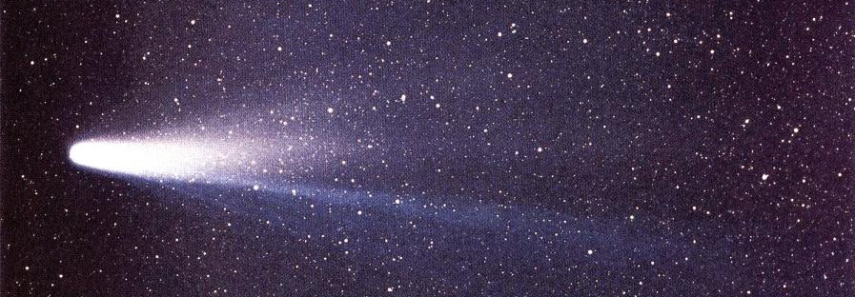  NASA
□ | Yes | - If yes, do you remember where you were at the time?  - Are you interested in astronomy? What about astrology?  - Have you ever wished upon a star?
□ | No
□ | I’m not sure

No. 3

If astronomers detect a planet-killing asteroid right before it hits Earth, do you want to know?
Yes, I would like to be able to prepare for the end. | 70% | 58930 votes
No, I would rather enjoy the last minutes without knowing. | 30% | 25007 votes
http://edition.cnn.com/2003/TECH/space/02/28/asteriod.alert/

Which of these adventures would you most like to have?
Climb Mount Everest | 8% | 47 votes
Dive with sharks | 3% | 17 votes
Drive Formula 1 race car | 15% | 88 votes
Fly in MiG jet | 15% | 88 votes
Orbit the Earth | 27% | 158 votes
Run with the bulls | 2% | 12 votes
Skydive | 8% | 47 votes
Visit South Pole | 10% | 59 votes
Something else | 11% | 64 votes
Don't know | 2% | 12 votes

Have you ever seen a comet?
Yes | 66% | 43,359 votes
No | 23% | 15,109 votes
I’m not sure | 10% | 6,843 votes

No. 3

