

POLL 1  Would you want to emigrate from your country? |  |  |  |  |  | 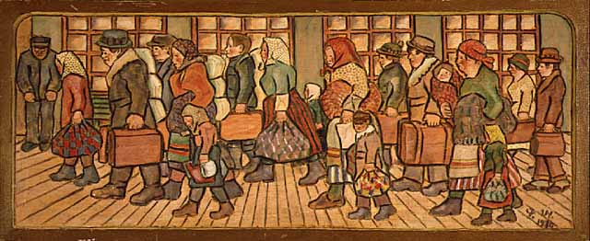  Minnesota Historical Society
□ | Yes |  | - Give reasons for your answer.  - What are some reasons to emigrate?  - What are some reasons not to emigrate?  - Other than your own country, which country would you like to live in? Why?  - Where is your favorite travel destination?  - Where would you like to travel to next?
□ | No

POLL 2
Which of the following is your favorite Oscar winning movie for Best Picture in the 90s?
□ |  | Dances with wolves (1990) |  | - Why is it your favorite?  - How many of these movies have you seen?  - Which of these movies is the worst one? Why do you think so?  - How often do you watch movies?  - Do you have a favorite movie genre?  - Do you think your choice is also the most popular?
□ |  | The Silence of the Lambs (1991)
□ |  | Unforgiven (1992)
□ |  | Schindler’s List (1993)
□ |  | Forest Gump (1994)
□ |  | Braveheart (1995)
□ |  | The English Patient (1996)
□ |  | Titanic (1997)
□ |  | Shakespeare in Love (1998)
□ |  | American Beauty (1999)
□ |  | I have not seen any of these films
□ |  | I did not like any of these films
POLL 3  How do you stop the hiccups? |  |  |  |  | 
□ |  | Hold my breath |  | - Do you often get the hiccups?  - Do you enjoy having the hiccups?  - Approximately how long do your hiccups last?  - Do you know of any other methods to stop the hiccups?  - Would you rather have the hiccups for 24 hours, or be trapped in an elevator for 24 hours?
□ |  | Breathe in to a paper bag
□ |  | Have a friend scare me

No. 2

Would you want to emigrate from your country?
Yes | 52% | 1919 votes
No | 48% | 1798 votes

Which of the following is your favorite Oscar winning movie for Best Picture in the 90s?
Dances with wolves (1990) | 3% | 47 votes
The Silence of the Lambs (1991) | 7% | 128 votes
Unforgiven (1992) | 2% | 28 votes
Schindler’s List (1993) | 5% | 94 votes
Forest Gump (1994) | 27% | 489 votes
Braveheart (1995) | 7% | 125 votes
The English Patient (1996) | <1% | 9 votes
Titanic (1997) | 31% | 572 votes
Shakespeare in Love (1998) | 1% | 26 votes
American Beauty (1999) | 4% | 68 votes
I have not seen any of these films | 9% | 168 votes
I did not like any of these films | 5% | 91 votes
http://www.funjoint.com/polls.htm

How do you stop the hiccups?
Hold my breath | 74% | 8332 votes
Breathe in to a paper bag | 20% | 2266 votes
Have a friend scare me | 6% | 642 votes

No. 2

