
POLL 1
How should toilet paper rolls be installed?
□ | Edge of roll facing wall (A) |  |  |  | 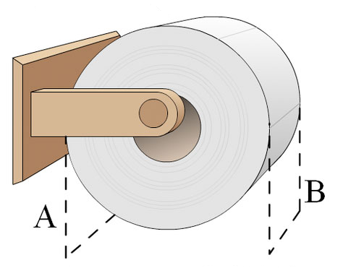avilis_ana
□ | Edge of the roll facing away from wall (B)
- Do you always install the toilet paper the same way?
- Does anyone in your family like it the opposite way?
- If a couple likes the toilet paper installed in different ways, could it lead to divorce?
- Do you prefer floral, scented toilet paper, or plain white and unscented?

POLL 2  What’s your most hated household chore? |  |  | - How often do you do house chores?  - Are there any chores that you don’t mind doing?  - Are you generally messy or neat?
□ |  | Vacuuming
□ |  | Dusting
□ |  | Scrubbing the kitchen floor |  |   ClkrFreeVectorIsdgtmages
□ |  | Taking out the garbage
□ |  | Cleaning the bathroom
□ |  | Cleaning the oven
□ |  | Doing yard work
□ |  | Washing dishes
□ |  | Cooking
□ |  | Cleaning up pet mess / litter box
POLL 3
What would you do if you were given an extra 20 dollar bill at the checkout counter of a supermarket? You only notice the mistake until after you’ve left the store.
□ |  | Keep the cash. It’s too late, too much hassle and it’s their mistake.
□ |  | Give half to charity. It’s a hassle to return it but I’d only keep half.
□ |  | It’s theft. Go straight to the cashier and hand the money back.
- Has this situation ever happened to you?  - Have you ever found money?  - Have you ever lost or been cheated out of money?  - Do you believe in karma? (what goes around, comes around)  - Agree or disagree: To be successful in business you have to be dishonest.  - Are dishonest people bad, or just looking out for #1?  - Are honest people good, or do they just have a guilty conscience? |  |  |  |  |  | 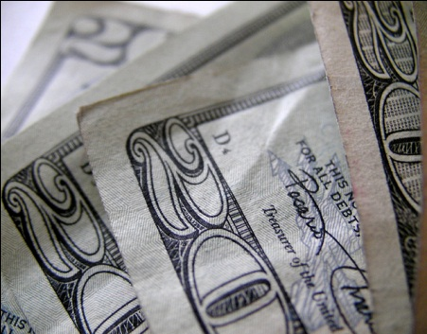Sh4rp_i

No. 1

How should toilet paper rolls be installed?
Edge of roll facing wall (A) | 21% | 768 votes
Edge of the roll facing away from wall (B) | 78% | 2730 votes
The Toilet Paper Roll Poll (http://www.probabilityof.com/toilet.shtml)

What’s your most hated household chore?
Vacuuming | 6% | 118 votes
Dusting | 6% | 188 votes
Scrubbing the kitchen floor | 5% | 111 votes
Taking out the garbage | 7% | 137 votes
Cleaning the bathroom | 23% | 475 votes
Cleaning the oven | 5% | 109 votes
Doing yard work | 9% | 188 votes
Washing dishes | 19% | 394 votes
Cooking | 2% | 38 votes
Cleaning up pet mess / litter box | 17% | 338 votes
http://www.funjoint.com/polls.htm

What would you do if you were given an extra 20 dollar bill at the checkout counter of a supermarket? You only notice the mistake until after you’ve left the store.
Keep the cash. It’s too late, too much hassle and it’s their mistake. | 75% | 4694 votes
Give half to charity. It’s a hassle to return it but I’d only keep half. | 2% | 116 votes
It’s theft. Go straight to the cashier and hand the money back. | 23% | 1466 votes

No. 1

